Diamond Composite: A “1+1 >2” Strategy to Design and Explore Advanced Functional Materials

Xinyue Chen^{a†}, Ximan Dong^{a†}, Xin Jiangª, and Nianjun Yang^{b*}

ª Institute of Materials Engineering, University of Siegen, 57076 Siegen, Germany
^{b} Department of Chemistry & IMO-IMOMEC, Hasselt University, Diepenbeek 3590, Belgium
* Email: nianjun.yang@uhasselt.be
† X.C and X.D contributed equally to this paper.

CONSPECTUS:
Diamond composite (DC) refers to a system which consists of diamond (Dia) and other components. Various interactions between diamond and other components exist. The first DC - Dia/β-silicon carbide (β-SiC) composite - was grown in 1992 by means of chemical vapor deposition (CVD) technique. Later on, the precise control of the distribution, crystallinity, and orientation of both diamond and β-SiC phases in these composites has been sequentially achieved, generating numerous Dia/β-SiC composites and further leading to their wide applications in diverse fields. Inspired by the activities of Dia/β-SiC composites, other DCs, produced using different CVD techniques, have been reported, including Dia/carbides, Dia/oxides, Dia/nitrides, Dia/sp²-carbon, Dia/metal, Dia/metal alloy, and Dia/organic composites. Meanwhile, these composites possess different micro- and nanostructures. Since DCs fully combine the outstanding properties of diamond with those of other components, their utilization in the mechanical, physical, chemical and biomedical fields have been extensively explored and tested. This “1+1 >2” strategy is believed to be extremely efficient and useful to design and explore advanced diamond functional materials. The origin of superior enhancement and/or new properties of these DCs using the 1+1 > 2 strategy stems from the interface and interactions between individual components as well as their synergistic effects.
This Account summarizes the progress and achievements of DCs in our group. Their typical synthesis methods, namely dry and wet ones are firstly overviewed. The dry methods are conducted in the gas phase(s), covering high-pressure high-temperature (HPHT) method, CVD method, physical vapor deposition (PVD). While the wet methods are mainly including electrochemical deposition and hydrothermal processes. The mechanical, and physical features of different Dia/β-SiC are then detailed. Some application examples of these Dia/β-SiC DCs are highlighted. In the second part of this Account, synthesis and applications of other DCs, especially those with photo/electro-chemical features are illustrated, for example the electrocatalysis of Dia/graphene composites toward oxygen reduction/evolution reactions (ORR/OER) and further the construction of flexible zinc-air batteries, the use of Dia/oxides (carbide) composites for the construction of battery-like supercapacitors, the employment of Dia/TiO₂ composites for photoelectrochemical degradation of environmental pollutants, the application of Dia/metal composites for electrochemical sensing. This Account is finished with the future prospects of DCs, encompassing their meticulous conceptualization and synthesis, as well as their multifarious applications across diverse domains.

1. Introduction
Diamond composite (DC) refers to a system which consists of diamond (Dia) and other components. Different from physically or mechanically mixed materials, different interactions exist between diamond and other components. In some cases, chemical bonds are even formed between diamond and the added components. Inside such DCs, diamond is extremely crucial since it owns many exceptional properties, encompassing robust mechanical attributes, elevated conductivity and activity levels, commendable chemical and thermal stability, as well as remarkable electrochemical characteristics once doped.^{1,2} The combination of diamond with other components, namely the synthesis of DCs using such a “1+1 > 2” strategy offers a new opportunity to design composite materials with artificially tailored properties. Namely, DCs integrate and further synergize the features of diamond materials with those of composite counterparts.³ Stemming from them, the reported DCs have been proved to be extremely promising in a wide range of application fields.⁴ Their unambiguous implications have been tested for mechanical, chemical and biomedical applications. The design and synthesis of DCs with controllable structures and tunable properties are thus of both fundamental and technological significance.^{5,6}
In this Account the DCs we discussed only refer to those where both diamond and component phases are exposed to air or to the electrolyte. Some reported DCs, such as co-doped diamond films (e.g., B-/N- co-doped diamond), core-shell DC structures (e.g., TiO₂ coated diamond, diamond coated nanotubes/fibers), lay-by-layer DC structures (e.g., Dia/SiC/Dia, graphene/Dia multilayers) are excluded. Our group initialized the DC growth (e.g., Dia/carbides, Dia/oxidizes) using a chemical vapor deposition (CVD) technique in 1992. Later on, other DCs have been designed and synthesized with similar CVD techniques or other approaches (Table 1). They can be categorized into two types: dry- and wet- methods. The former ones are generally conducted in the gas phase(s), covering high-pressure high-temperature (HPHT) method, CVD method, physical vapor deposition (PVD), laser treatment, etc. While the latter ones are commonly conducted in solutions, mainly including electrochemical deposition and hydrothermal processes.
In past decades, we have been working on the application of this “1+1 > 2” strategy to design and explore numerous DCs. Figure 1 displays some typical scanning electron microscopy (SEM) images of our DCs in a chronological order. Although these DCs have been employed for various applications, we only highlight some of them as case studies in this Account, including the nanoindentation and protein adsorption of Dia/SiC composites,⁷⁻¹¹ the electrocatalysis of Co₄N nanoparticles nitrogen-doped graphite/Dia composites (Co₄N@Gr/Dia) toward oxygen reduction/evolution reactions (ORR/OER) and further the construction of flexible zinc-air batteries,¹⁸ the supercapacitor fabrication using Dia/MnO₂,¹² Dia/carbon nanofibers (Dia/CNFs),¹³ Dia/TiC,¹⁴ Mn-BDD²⁴ and Dia/graphene (Dia/Gra)²², the photoelectrochemical degradation of environmental pollutants using Dia/TiO₂ patterns,²¹ and electrochemical sensing using CuO@graphite/Dia (CuO@C/Dia) composites.²³

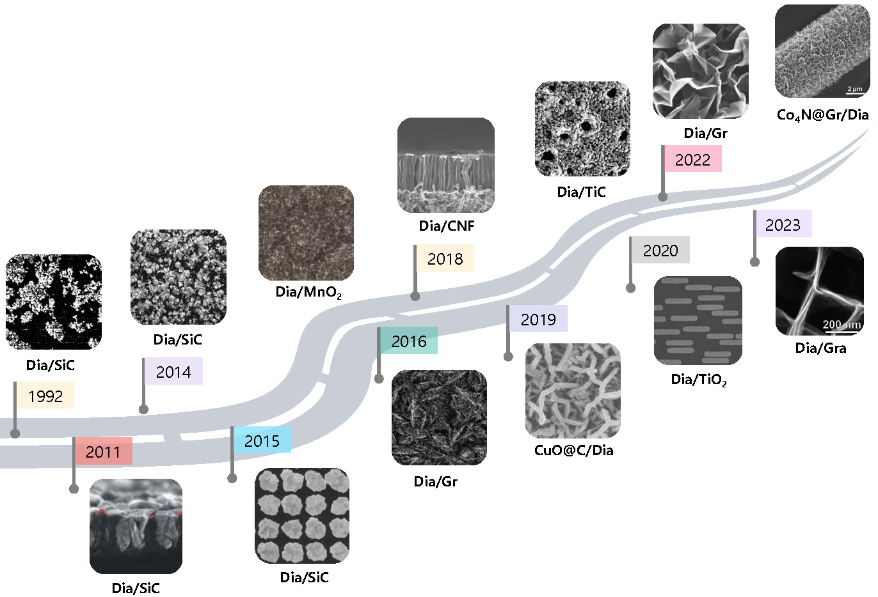
Figure 1. SEM images of several typical DCs that were designed and synthesized in our group since 1992. Reproduced with permission from ref 7. Copyright 1992 AIP Publishing. Reproduced with permission from ref 9. Copyright 2011 Elsevier. Reproduced with permission from ref 11. Copyright 2014 Elsevier. Reproduced with permission from ref 35 Copyright 2015 Springer International Publishing. Reproduced with permission from ref 12. Copyright 2015 American Chemical Society. Reproduced with permission from ref 16. Copyright 2016 Elsevier. Reproduced with permission from ref 13. Copyright 2018 Wiley-VCH. Reproduced with permission from ref 23. Copyright 2019 Wiley-VCH. Reproduced with permission from ref 14. Copyright 2019 Wiley-VCH. Reproduced with permission from ref 18. Copyright 2023 Wiley-VCH. Reproduced with permission from ref 21. Copyright 2020 Wiley-VCH. Reproduced with permission from ref 20. Copyright 2021 IOP Publishing. Reproduced with permission from ref 22. Copyright 2023 Wiley-VCH.

Table 1. Summary of reported synthesis methods and applications of various DCs.
DC | Technique  (gas precursors) | Synthesis details | Application | Ref.
Dia/β-SiC | MWCVD  (H₂/CH₄/TMS) | different substrates (W and Mo) | Nanoindentation | 25
Dia/β-SiC | MWCVD  (H₂/CH₄/TMS) | varied growth temperatures | Tribology | 17
Dia/β-SiC | MWCVD  (H₂/CH₄/TMS) | different TMS flow rates | Nanoindentation | 26
Dia/β-SiC | MWCVD  (H₂/CH₄/TMS) | different TMS/CH₄ ratio | Si-vacancy (SiV) centers | 30
Dia/β-SiC | MWCVD  (H₂/CH₄/TMS) | different growth times | Nanoindentation | 31
Dia/β-SiC | HFCVD  (H₂/CH₄/TMS) | with gradient composition | Biomedicine | 28
Dia/β-SiC | HFCVD  (H₂/CH₄/TMS) | with gradient composition | Controlling directional Liquid motion | 29
Dia/graphite | MWCVD  (H₂/CH₄) | different treatment time | Electron Field Emission | 19
Dia/graphite | MWCVD  (H₂/CH₄) | different H₂/CH₄ ratio | Electrochemical  Sensors | 15
 |  |  |  | 16
CuO@graphite  /Dia | MWCVD  (H₂/CH₄) | DC magnetron sputtering of CuO and electrochemical oxidation | Electrochemical  Sensors | 23
Dia/N-doped graphite | MWCVD  (H₂/CH₄) | different flow rates of N₂ | Electrocatalysts  (OER) | 20
Dia/graphene | MWCVD  (H₂/CH₄) | electrochemical intercalation | EDL model | 22
Dia/Co₄N nanoparticles nitrogen-doped graphite | MWCVD  (H₂/CH₄) | electrochemical deposition  TCVD process  electrochemical oxidation | Zinc-Air Batteries | 18
BDD/TiO₂ | MWCVD  (H₂/CH₄/TMB) | different exposure ratios of the BDD patterns and TiO₂ | Photo-electrocatalysis | 21
BDD/Carbon nanofiber | MWCVD  (H₂/CH₄/TMB) | TCVD process using Cu to grow CNFs with C₂H₂ gas | Supercapacitor | 13
BDD/TiC | MWCVD  (H₂/CH₄/TMB) | Plasma-Electrolytic-Oxidized treatment of Ti plates | Supercapacitor | 14
BDD/MnO₂ | MWCVD  (H₂/CH₄/TMB) | electrodeposition of MnO₂ | Supercapacitor | 12
NDD/graphite | MWCVD  (H₂/CH_{4/}N₂) | immersed in a mixture of H₂SO₄ and HNO₃ for 30 min | Supercapacitor | 27
BDD: boron-doped diamond; NDD: nitrogen-doped diamond; MWCVD: microwave plasma-enhanced chemical vapor deposition; HFCVD: hot filament chemical vapor deposition; TCVD: thermal chemical vapor deposition; TMS: tetramethylsilane; DND: detonation nano diamond; PDMS: poly(dimethylsiloxane); TMB: trimethylborane; CNF: carbon nanofibers; EDL: electrical double-layer

- Dia/SiC Composites
2.1 Synthesis
Prior to Dia/SiC composites, it is worth mentioning about Dia/Gr composites. It is known that the synthesis of artificial diamond via the HPHT method was unitized in 1955, while artificial diamond growth was expanded through CVD techniques till the 1980s.^{32,33} The distinct steps of diamond growth on non-diamond substrates during CVD processes are believed to involve (Figure 2) substrate pre-treatment (e.g., cleaning, etching), seeding/nucleation, and growth within a CVD chamber. Prior to diamond growth, a mix of hydrocarbon gas (usually methane) and high-concentration hydrogen (≈ 95%) needs to be purged into the CVD chamber. Hydrogen abstraction serves a dual role during diamond growth: extracting hydrogen from the hydrocarbon gas, creating a methyl radical (CH₃⁻), and forming active radical sites on hydrogen-terminated surfaces conducive to adding carbon radicals (CH₃⁻). Simultaneously, hydrogen radicals remove non-diamond carbon from the substrate, yielding high-quality diamond films. Varying hydrocarbon gas concentration (e.g., methane) yields distinct diamond growth patterns. Lateral growth, two-dimensional (2D) terrace nucleation, and three-dimensional (3D) growth of diamond films are thus possible. Once the concentration of the hydrocarbon gas exceeds a critical point during the diamond growth process, a mixture of diamond and non-diamond carbon materials, namely DCs can be synthesized. For example, the augmenting of methane concentration led to the growth of diamond/graphite (Dia/Gr) composites.¹⁷ The morphologies of these Dia/Gr composites (e.g., 3D-networked, nanoplatelets, nanowalls) were even tailorable, as confirmed from their SEM images (Figure 2a), TEM images (Figure 2b) as well as Raman spectra (Figure 2c). Note that they were simply tunable through adjusting the growth parameters (e.g., flow rate of methane, growth temperature, and microwave power).¹⁷
Meanwhile, other components (e.g., carbides) have been introduced during the diamond CVD growth processes. This strategy was testified in 1992 for the first time for the synthesis of Dia/β-SiC composites. Inside a microwave plasma enhanced CVD (MWCVD) reactor, methane and tetramethylsilane (TMS) were employed as the precursors to grow diamond and β-SiC phases, respectively. The variation of growth conditions (e.g., concentrations of gas precursors, power density, growth temperature) resulted in the growth of different Dia/β-SiC composites that featured different morphologies, crystal orientations, and phase concentrations. A hydrogen-induced and selective growth model was further proposed to demonstrate the growth mechanisms of these Dia/β-SiC composites.³⁵ Here, the key assumption is that only SiH₃ and CH₃ are stably bonded to β-SiC and diamond phases, respectively. The non-stable SiH₃ species on the diamond phase and the non-stable CH₃ species on the β-SiC phase are immediately etched away by highly energetic hydrogen radicals. The surface is then re-saturated with H bonds. Such two successive processes lead to the formation of the Dia/β-SiC composites, as demonstrated from their SEM images (Figure 2d,e), XRD patterns (Figure 2f) and Raman spectra (Figure 2g).⁹
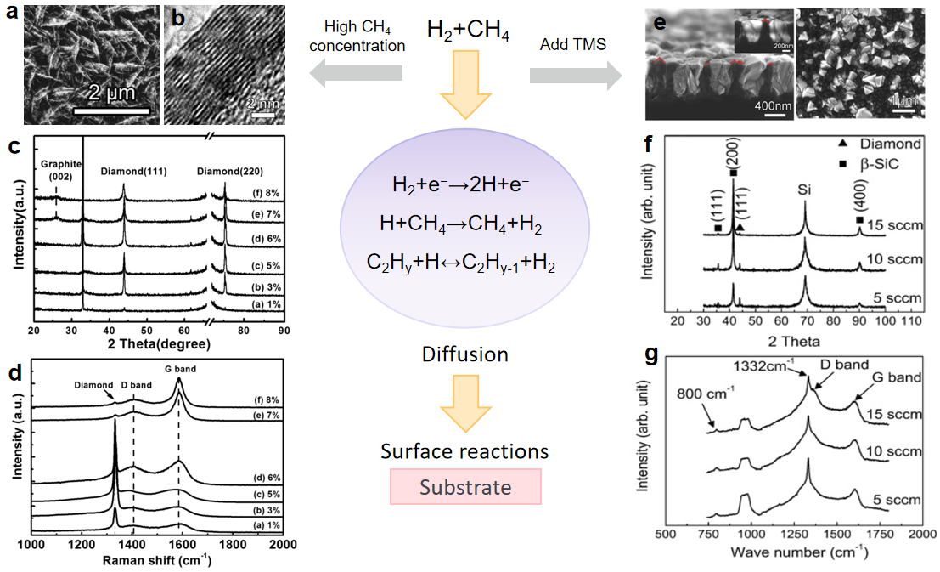
Figure 2. Synthesis and characterization of Dia/Gr (a,b,c) and Dia/β-SiC (d,e,f,g) composites: (a) SEM and (b) TEM images, (c) XRD patterns and (d) Raman spectra of Dia/Gr composites; (e) SEM images, (f) XRD patterns and (g) Raman spectra of Dia/β-SiC composites. Reproduced with permission from ref 9. Copyright 2011 Elsevier. Reproduced with permission from ref 17. Copyright 2016 Elsevier.

2.2 Properties
2.2.1 Mechanical aspect
The mechanical properties of DCs are confirmed as a function of their compositions. The combination of DCs can create synergies, where the strengths of one material compensate for the weaknesses of another. For instance, while diamond may be hard but brittle, the addition of another component might improve toughness without compromising hardness significantly. For example, the hardness of Dia/β-SiC composites was found to be reduced with an increase of the β-SiC content inside these composites. Experimentally, the phase contents of diamond and β-SiC phases have been in-situ adjusted by varying the added content of gas precursor - TMS (Figure 3a).³⁷ The estimated thermal expansion coefficient and hardness of a β-SiC-rich Dia/β-SiC composite were 4 × 10⁻⁶ K⁻¹ and 30 GPa, respectively. They are close to those values of WC-6% Co, a widely used cutting tool material. A gradient form of Dia/β-SiC composites was further utilized to achieve biaxial stress-free diamond top layers, where diamond films possess remarkably low compressive stresses - only 0.04 GPa. Such a low stress value was assigned to the structure of this DC, where a Dia/β-SiC gradient nanocomposite acts as an interlayer with diamond serving as the top layer. This interlayer significantly accommodates the stress that is caused by the difference in thermal expansion coefficient between diamond film and the underlying substrate.³⁸
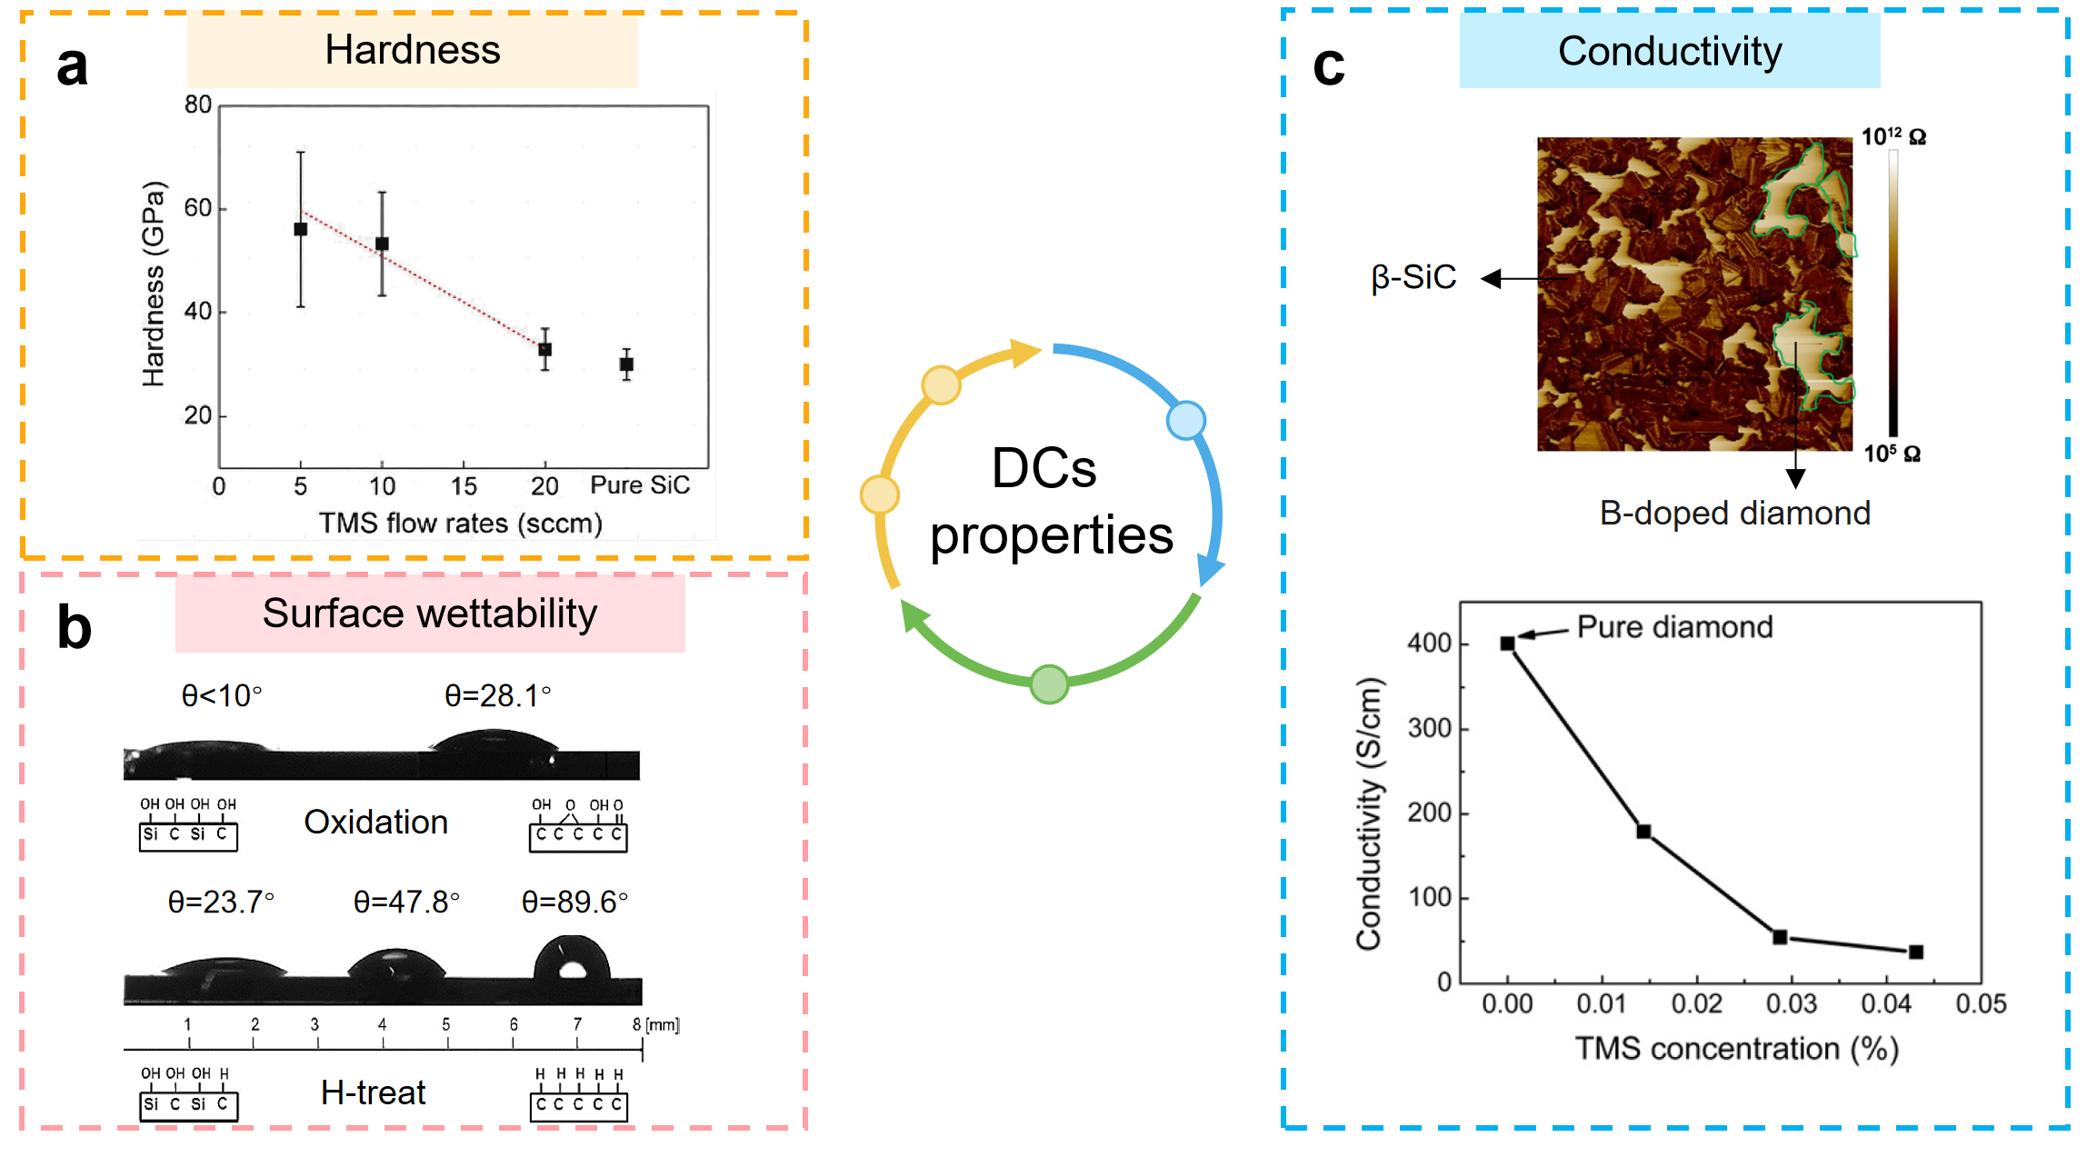
Figure 3. Dia/SiC properties: (a) Berkovich hardness variation with different TMS flow rates;³⁷ Reproduced with permission from ref 37. Copyright 2019 John Wiley & Sons. (b) Contact angle measurements of water drops on the gradient Dia/SiC composites after oxidation and H-termination treatment of individual β-SiC phase (left side) to individual diamond phase (right side);²⁸ Reproduced with permission from ref 28. Copyright 2014 American Chemical Society. (c) Topographical mapping of a BDD/β-SiC composite and the variation of its electrical conductivity with the applied TMB concentration during the growth;⁴¹ Reproduced with permission from ref 41. Copyright 2017 AIP Publishing.

2.2.2 Physical aspect
The physical properties of DCs (e.g., surface wettability, conductivity) might be different from individual diamond materials or the composite counterparts. The interaction and interface between the constituents in a composite play a critical role. In a well-designed DCs, the interface between diamond and the other component (e.g., silicon carbide) can introduce new properties or enhance existing ones. This interaction might lead to improved bonding, altered electronic structures, or modified surface characteristics that contribute to enhanced overall performance. Various DCs are expected to own different surface wettability, namely varied hydrophilic or hydrophobic features. For example, Dia/β-SiC composites exhibited controllable/tunable surface wettability, which has been realized by adjusting the compositions of both diamond and β-SiC phases. It was achieved through selective H-termination of diamond phase and OH-termination of β-SiC phase inside the Dia/β-SiC composites (Figure 3b). This is readily doable since diamond can be easily H-terminated with the H₂ plasma treatment, while the H-termination of β-SiC surface is known to be difficult under identified condtions.^{28,29} However, the treatment of β-SiC in HF solutions can result in its OH-termination, while diamond is stable in HF solution. Simultaneous H-termination of diamond phase and OH-termination of β-SiC inside Dia/β-SiC composites were then achieved by the first chemical oxidization of Dia/β-SiC composites, followed by their H₂ plasma treatment.²⁸ These treated Dia/β-SiC composites featuring different and localized surface terminations are thus suitable for diverse technological activities where varied surface wettability is required.
Since the component contents inside DCs are variable in some ranges, the electrical properties of DCs are possible to be accordingly altered to some degrees.^{39,40} Taking a Dia/β-SiC composite as an example, its conductivity was revealed to be dependent on the concentration of doped boron atoms or directly the concentration of added precursors (e.g., TMB). An increase of the boron concentration from 30 to 90 ppm led to significantly increased conductivities (σ) of related DCs, namely from 5 to 15 S cm⁻¹. A further addition of TMB even led to a conductivity of as high as 100 S cm⁻¹.⁴¹ In this case, two regions corresponding to β-SiC crystals appear - highly conductive and non-conductive areas. (Figure 3c). The former exhibited a resistance of 10⁶ Ω, while the latter showed a resistance of 10¹¹ Ω. The huge or about 5-orders difference in the conductivities of diamond and β-SiC phases was believed to originate from the different energy levels of the boron acceptor in diamond and β-SiC phases. Boron forms shallow acceptor levels in the diamond phase, depending on its incorporation. In this context, the addition of TMB into diamond results in a high room temperature conductivity of the diamond phase. However, boron only forms a deep acceptor level (0.735 V) inside the β-SiC phase, even though there might be a high incorporation of boron in the β-SiC phase. Stemming from its large binding energy, the thermal energy at or below room temperature is not sufficiently high to generate a substantial number of holes for the conduction band. The boron-derived acceptor levels were believed to effectively trap carriers, resulting in a poor conductivity of the β-SiC phase at room temperature.⁴⁰

2.3 Applications
2.3.1 Mechanical field
In spite of excellent mechanical properties (e.g., high hardness and strength, good thermal conductivity and low coefficient of friction), diamond thin films have been proved not to be perfect protective layers, resulting from their poor adhesion to technologically important materials (e.g., metals). The main obstacle is the large residual stress at the diamond/substrate interface, stemming from significant differences in thermal expansion coefficients and hardness between diamond films and the substrates. To solve these challenges, a Dia/β-SiC composite has been employed as a graded interlayer between the substrate (e.g., Si^{30,51}, W, Co⁵²) and the top diamond layer. The β-SiC layer boasts remarkable hardness and exceptional wear resistance. The combination of diamond and β-SiC layers can overcome some limitations of their individual uses and create materials with better properties to meet the requirements for wear resistance, hardness, durability and service life. The residual stress at the interface between diamond and the substrate is thus significantly reduced.
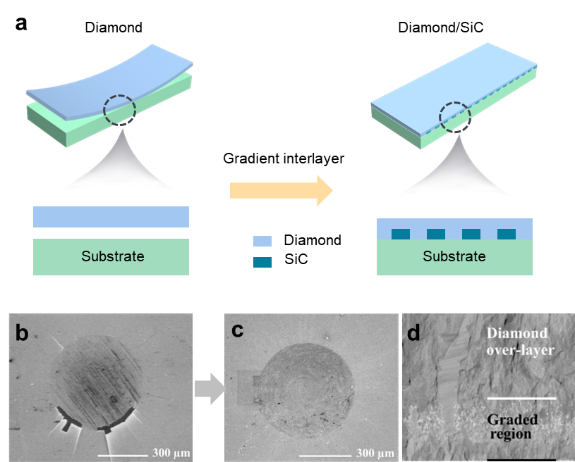
Figure 4. Mechanical applications of Dia/SiC composites: (a) Schematic diagram of solving insufficient adhesion of diamond by introducing a gradient composite film. The comparison of SEM images on the indentation zones between delamination of (b) a diamond film directly coated method and (c) a gradient composite.²⁵ Reproduced with permission from ref 25. Copyright 2007 Elsevier. (d) Cross-sectional SEM image of a gradient composite deposited on a Si substrate.³⁸ Reproduced with permission from ref 38. Copyright 2009 Elsevier.

Such a stress was further alleviated by manipulating the distribution of both diamond and β-SiC phases in the interlayer, which were grown using either MPCVD^{25,26,32-34} or HFCVD^{9,10,23} techniques. To deposit gradient composite interlayers, the TMS flow rate was gradually reduced. Once the flow rate of TMS was zero, a diamond top layer was grown. The advantage of this approach was the simultaneous growth of both a diamond top layer and a gradient composite interlayer within a single process. Since residual stress was gradually released in the gradient layer, the top diamond layer was nearly stress-free whatever on a Si substrate or metal substrates.^{25,26} The reduced residual stress thus improved the adhesion of a diamond film on the related substrates (Figure 4). Such a statement was further confirmed with the Brinell indentation tests.²⁵ In the case of a pure diamond film directly coated on the W and Mo substrates, an indentation load of 62.5 kgf was sufficient to induce significant film delamination. However, when a gradient interlayer was introduced, the film delamination did not occur up to a normal load of 100 kgf. A load higher than 100 kgf initiated a crack formation. However, a diamond film remained to be attached to the substrate. The gradient composite interlayer was further applied to improve the adhesion of diamond films on Co-cemented tungsten carbide (WC-Co) cutting inserts.^{43,44} The presence of cobalt silicides (namely Co₂Si, CoSi) in the DCs was suggested from the diffusion of cobalt atoms into the Si bulk material. These cobalt silicides were proved to enhance the adhesion of the diamond coating on the WC-Co substrates.⁴⁵
The mechanical performance of these Dia/SiC composite films were further quantitatively and accurately determined. The disturbing effect of the roughness from the as-deposited surface was mitigated by indenting from the initially grown surface. A two-step method was developed, consisting of transferring a thin film to a polished steel and subsequent removal of the silicon substrate in a hot base solution. The smoothness or surface roughness (R_{a}) of an initially grown surface was estimated to be only about 1 nm. The elastic modulus and the hardness of this homogeneous Dia/SiC composite were measured to be 598 ± 25 GPa and 49.8 ± 2.1 GPa, respectively. Additionally, the determined moduli of these composites using the proposed method were in good agreement with surface acoustic wave results.³¹ Meanwhile, its fracture toughness was enhanced to 11.1 ± 1.1 MPa m^{1/2}.⁴² Such a value is of extreme significance since the fracture toughness is known to be the critical for the investigation of crack morphology and the appropriate selection of reference materials to ensure reproducible evaluation of fracture toughness for any unknown material.

2.3.2 Biomedical field
Since most DCs can have different surface topography and controllable surface chemistry, they are thus perfect candidates for biomedical applications, such as the investigation of biomolecular adsorption.^{46,47} Unfortunately, the studies about diamond composites for real biomedicine applications are relatively rare, different from those widely studied using pure diamond materials. This is because diamond maintains long-term surface stability and durability, extraordinary biocompatible and electronic during the protein adsorption process. It is not vulnerable to acid, alkali and other chemical substances erosion, helping to keep the stability of the protein adsorption process. In addition, the diamond surface can be surface functionalized to increase specific adsorption sites or change surface properties to improve the interaction with proteins.
Here it is worth mentioning that the Dia/β-SiC gradient composites showcases their potential for biomedical real applications. For example, a Dia/SiC composite is expected to be highly stable and extremely suitable for implants or biosensors. However, both the diamond and β-SiC phases in a Dia/SiC composite are chemically inert, its surface functionalization or the control of its surface terminations is thus a must prior to the attachment of biomolecules on its surface. The desired functional molecules or linkers (e.g., nitrophenyl molecules) have been grafted by means of photochemical, electrochemical and thermal methods. The variation of surface terminations (e.g., H-, OH-, OOH-, and -C=O- terminations) on both diamond and SiC phases inside the Dia/SiC composites has been tried using different dry (e.g., plasma treatment) and wet (e.g., chemical oxidation) methods.⁴⁸ With these functional groups, namely grafted molecules and different surface terminations, the Dia/SiC composites were proved to be biologically active and have been employed for different biomedical applications, such as facilitating selective protein and cell adsorption to guide cell migration.
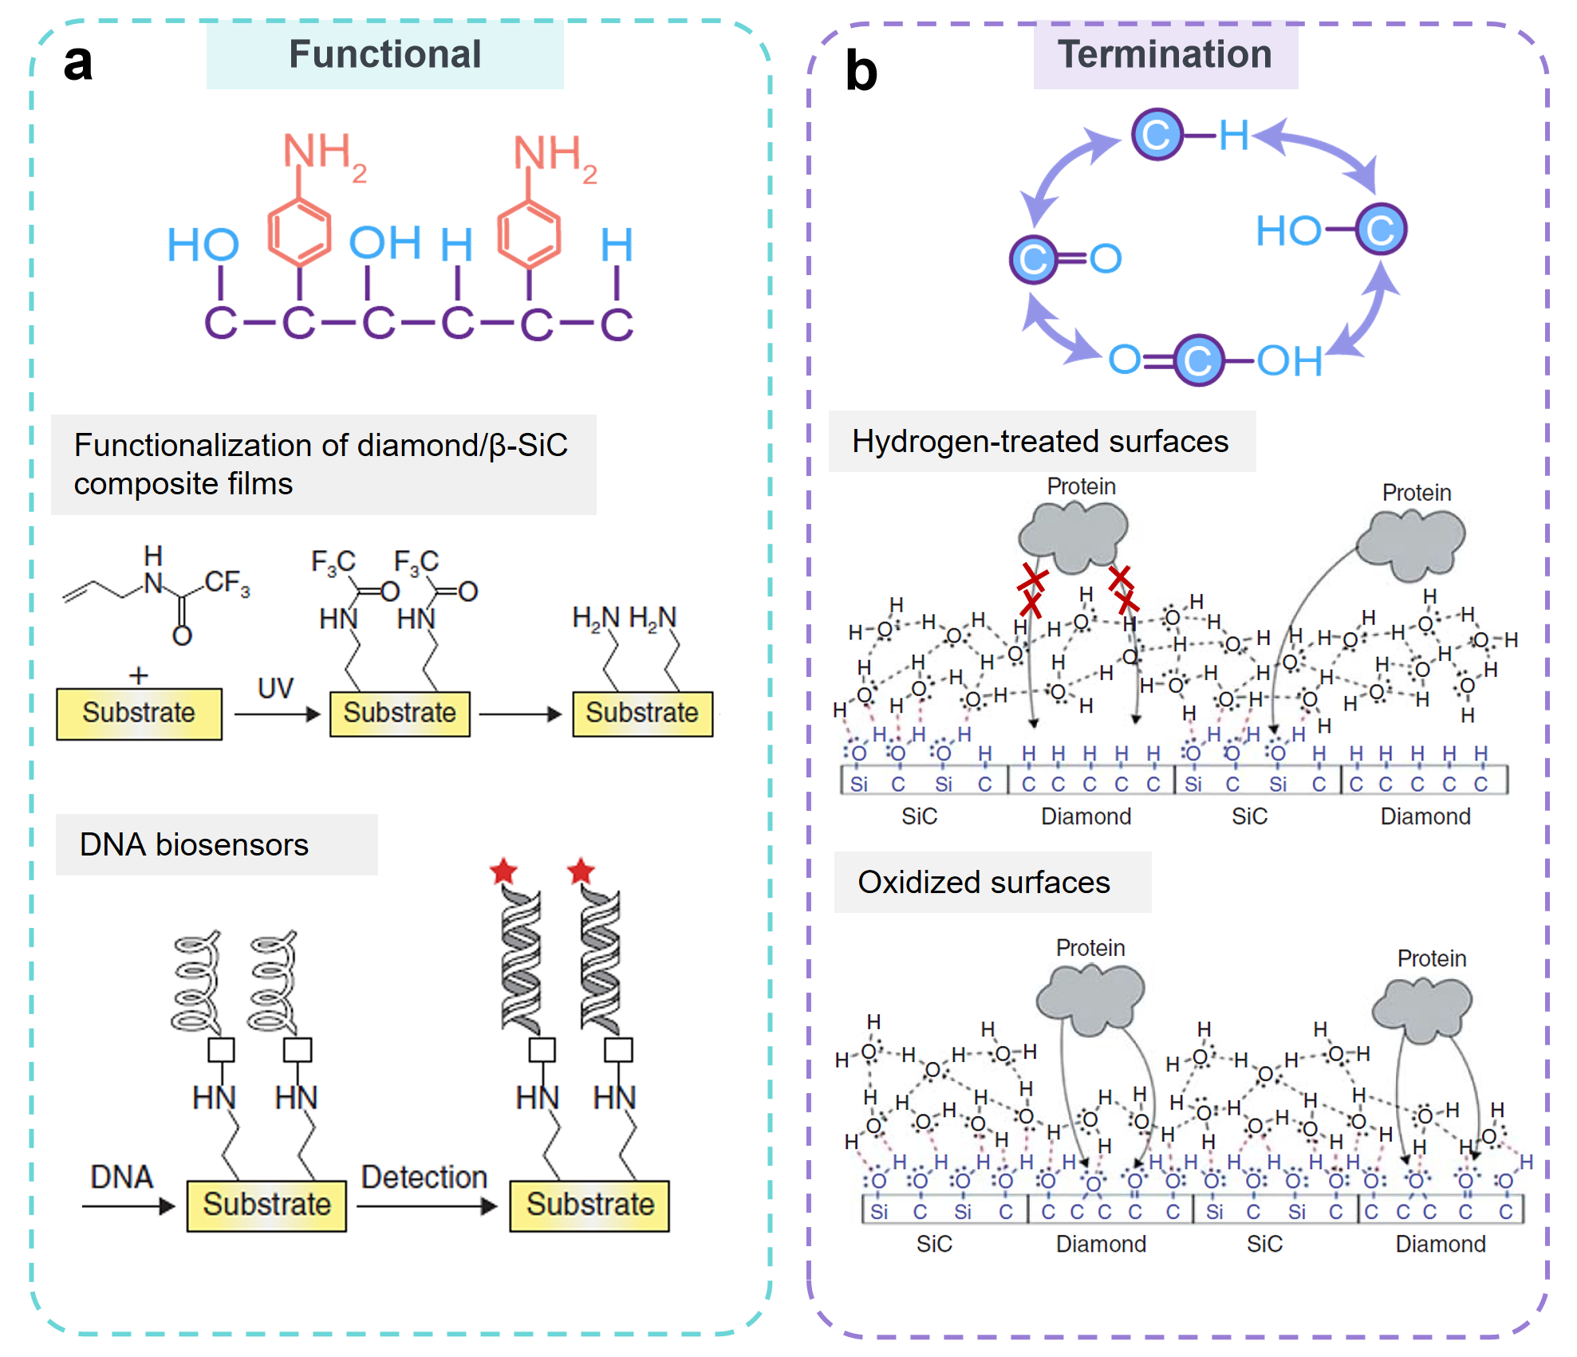
Figure 5. Biomedical applications of Dia/SiC composites: (a) Schematic diagram of diamond surface functionalization and the main steps during photochemical functionalization for DNA biosensor applications.³⁵ Reproduced with permission from ref 35. Copyright 2015 Springer Nature. (b) Schematic diagram of terminal transformation of functional groups for selective protein adsorption.²⁸ Reproduced with permission from ref 28. Copyright 2014 American Chemical Society.

Taking a photochemical method an example, it has been developed to functionalize a Dia/SiC composite, namely by the attachment of allylamine to the Dia/SiC surface (Figure 5a).³⁵ The amino group was protected by a trifluoroacetic acid group in order to prevent the oxidation of this linker molecule and the Dia/SiC composite during the UV illumination. After the amine group was deprotected and attached to a single-stranded DNA, the detection of the DNA hybridization event was conducted in a solution containing fluorescent dye. In another example, protein adsorption on the Dia/SiC composite surfaces has been partially controlled via varying surface terminations of two phases (namely OH-terminated β-SiC phase and OH-/H-terminated diamond phase as well as adjusting diamond/ β-SiC phase ratios in the composites.^{28,49,51} Post-oxidation treatment of a Dia/β-SiC gradient composite led to proteins (bovine serum albumin and fibrinogen) favoring diamond over β-SiC surfaces, while after H-treatment proteins preferred β-SiC over diamond surfaces (Figure 5b). To underly this preference, Mechanisms were explored after considering hydrogen bonding within a water self-association network on OH-terminated surfaces and the changes in the polar surface energy component. Experimental determination using the van Oss method and static contact angle measurements using various probe liquids (e.g., water, diiodomethane, glycerol, ethylene glycol) confirmed varied surface wettability on these phases.^{50,51} Therefore, controllable protein adsorption on Dia/β-SiC gradient composites showcases their potential for real biomedical applications since they facilitate selective protein and cell adsorption to guide cell migration.

3. Other DCs
3.1 Synthesis
Some alternative approaches have been presented to prepare other DCs, including the CVD growth of diamond on structured substrates, the cultivation of diamond on the surface of other materials, the continuous growth of other materials on top of diamond. For example, a porous boron-doped diamond/titanium carbide (BDD/TiC) composite was synthesized using a plasma electrolytic oxidation (PEO)-treated titanium plate as the substrate, followed by the CVD diamond growth inside a MWCVD reactor.¹⁴ In the patterned Dia/TiO₂ composites, the exposure ratio of diamond to TiO₂ was simply varied by altering the area/amount of the sputtered TiO₂ thin film on the diamond surface.²¹ Vertically aligned carbon nanofibers (CNFs) were coated on a diamond film, where a nanometer-thick copper layer sputtered on the diamond surface acted as the catalyst for the thermal CVD growth of CNFs and acetylene was the precursor. The dimensions and densities of the CNFs were varied as a function of the features of the sputtered copper catalyst (e.g., thickness) and the growth parameters (e.g., growth duration and acetylene concentration).¹³
In addition, some methods in liquid phases were applied to prepare DCs. In most cases, the components (e.g., metals, polymers, and metal oxides) are directly deposited onto the diamond surface using electrochemical deposition or chemical reactions. One recent example is electrochemical deposition of MnO₂ layers on the diamond surface, of which thicknesses were regulated by modulating the deposition times and the applied current densities.¹² The Dia/Pt composites were obtained through the electrodeposition of Pt particles on the diamond electrode surface.³⁶ The CuO@C/Dia and Dia/Gr composites have been produced via sputtering and electrochemical intercalation methods, respectively.^{22,23}

3.2 Properties
Electrochemical intercalation of sulfuric acid molecules or related ions into vertically aligned Dia/Gr composites, more precisely into graphene layers has been conducted at different voltages. Different intercalation voltages made these Dia/Gra composites exhibit varied volumetric capacitances (Figure 6a). When the applied voltage was 1.4, 1.6, and 1.8 V, the capacitances of these Dia/Gra composites were 1.5, 6.7, and 16.5 mF cm⁻², respectively.²² Their double layer capacitances of such expanded Dia/Gra composites are thus altered with the spacing of the expanded graphene layers or the sizes of the graphene channels.
A wide potential window is the second feature of these DCs. Doped or conductive diamond and DC composites are believed to be superior to most electrodes. This is because the potential window of a working electrode is one of the important parameters when evaluating electrochemical applications of an electrode.⁵² For example, the potential window of a Dia/Gr composite that was fabricated with a methane concentration of 8% was about 3.1 V in 0.1 M H₂SO₄ when a current density of 0.9 mA cm⁻² was selected as a turning point (Figure 6b). This value is comparable to that of a BDD electrode and significantly wider than that of an exfoliated graphite electrode (~ 2.2 V).¹⁶
In addition, DC composites exhibit high activities toward both inner-sphere Fe(CN)₆^{3-/4-} and outer-sphere Ru(NH₃)₆^{2+/3+} redox probes.^{53,54} Once DC composites and redox probes are changed, electrochemical response is varied accordingly.⁵⁵ Another example is in photoelectrochemical properties, a p-n heterojunction Dia/TiO₂ was synthesized using uniform patterns of a p-type BDD film and a n-type anatase TiO₂ film. The exposure ratios of the BDD patterns were varied to tune the photo-electrocatalytic abilities of this heterojunction. A heterojunction with a BDD exposure ratio of 20% exhibited a photocurrent density of 0.63 mA cm⁻², which is 2.86-fold higher than that obtained on a BDD film and 1.91-fold higher than that obtained on a TiO₂ film coated on a BDD film (Figure 6c).²¹
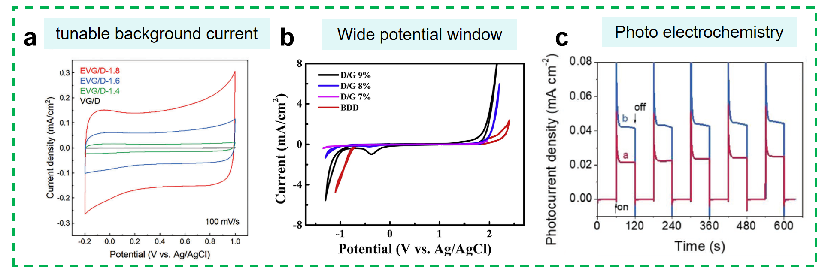
Figure 6. Electrochemical properties of DCs: (a) The comparison of the cyclic voltammograms (CVs) of a BDD/Gra composite;²² Reproduced with permission from ref 22. Copyright 2023 Wiley-VCH. (b) CVs of several Dia/Gr composites and a BDD film at 50 mV s⁻¹ in 0.1 M H₂SO₄;¹⁶ Reproduced with permission from ref 16. Copyright 2016 Elsevier. (c) Variation of photocurrent densities of a TiO₂/BDD composite in 0.1 M Na₂SO₄ aqueous solution in the dark and under light irradiation.²¹ Reproduced with permission from ref 21. Copyright 2020 Wiley-VCH.

3.3 Applications
The most important advance of these DC electrodes is that they remain the features of doped diamond materials, such as wide electrochemical potential windows, low background currents, long-term stability, and environmental benignity. Meanwhile, the functions of other components are fully integrated with those of diamond materials. Therefore, these DCs have been widely explored in the fields of electrosynthesis, electrocatalysis, electrochemical energy storage and conversion, electrochemical sensing, and electrochemical devices. In the past years DCs with diverse components have been frequently utilized as electrodes such as Dia/CNF,¹³ porous Dia/TiC,¹⁴ Dia/MnO₂,¹² Dia/Gr,²⁷ and Dia/TiO₂²¹.

3.3.1 Electrocatalysis
Some DCs have been employed as electrocatalysts for different catalytic reactions. For example, nitrogen-doped graphene/Dia (N-Gr/Dia) composites, composed of a thin nano diamond layer at the bottom and vertically aligned multigraphene layers on the surface (Figure 7a), have been treated by thermal annealing and then applied for the ORR. They exhibited superior ORR performance, namely a high onset potential of 835 mV (vs. standard hydrogen electrode, RHE) as well as excellent stability (e.g., 90% current retention even after an electrolysis time of 20 h). Their high performance was attributed to the activation and exposure of graphene edge sites along with the presence of a bonded nano diamond layer.²⁰ The Co₄N@Gr/Dia composites were further synthesized on carbon cloth (as the current collector). As bi-functional catalysts for both ORR and OER, they exhibit superior performance (Figure 7b). The potential gap was as small as 0.75 V. They were further employed as air electrodes to assemble flexible zinc-air batteries, demonstrating an open circuit voltage of 1.41 V and excellent bending stability.¹⁸

3.3.2 Supercapacitors
Some DCs have been employed as the capacitor electrodes to improve the capacitances of diamond-based supercapacitors^{.24} This is because the component phase is possible to reduce the charge transfer resistance (R_{ct}) of the DCs, facilitating rapid ion and electron transportation.⁵³ For instance, a porous BDD/TiC electrode delivered a specific capacitance of 46.3 mF cm⁻² at 1 mA cm⁻², which was greater than that of individual TiC and BDD electrodes under identical conditions (Figure 7c).¹⁴ To fabricate supercapacitors with both high power- and energy- densities as well as large and stable capacitances, the Dia/CNFs composites were utilized as the capacitor electrodes. The assembled two-electrode symmetrical electrical double-layer capacitor (EDLC) and pseudocapacitor (PC) devices exhibited the capacitances of 30 and 48 mF cm⁻² at 10 mV s⁻¹, respectively. Their power densities were 27.3 and 25.3 kW kg⁻¹, along with their energy densities of 22.9 and 44.1 Wh kg⁻¹, respectively (Figure 7d).¹³
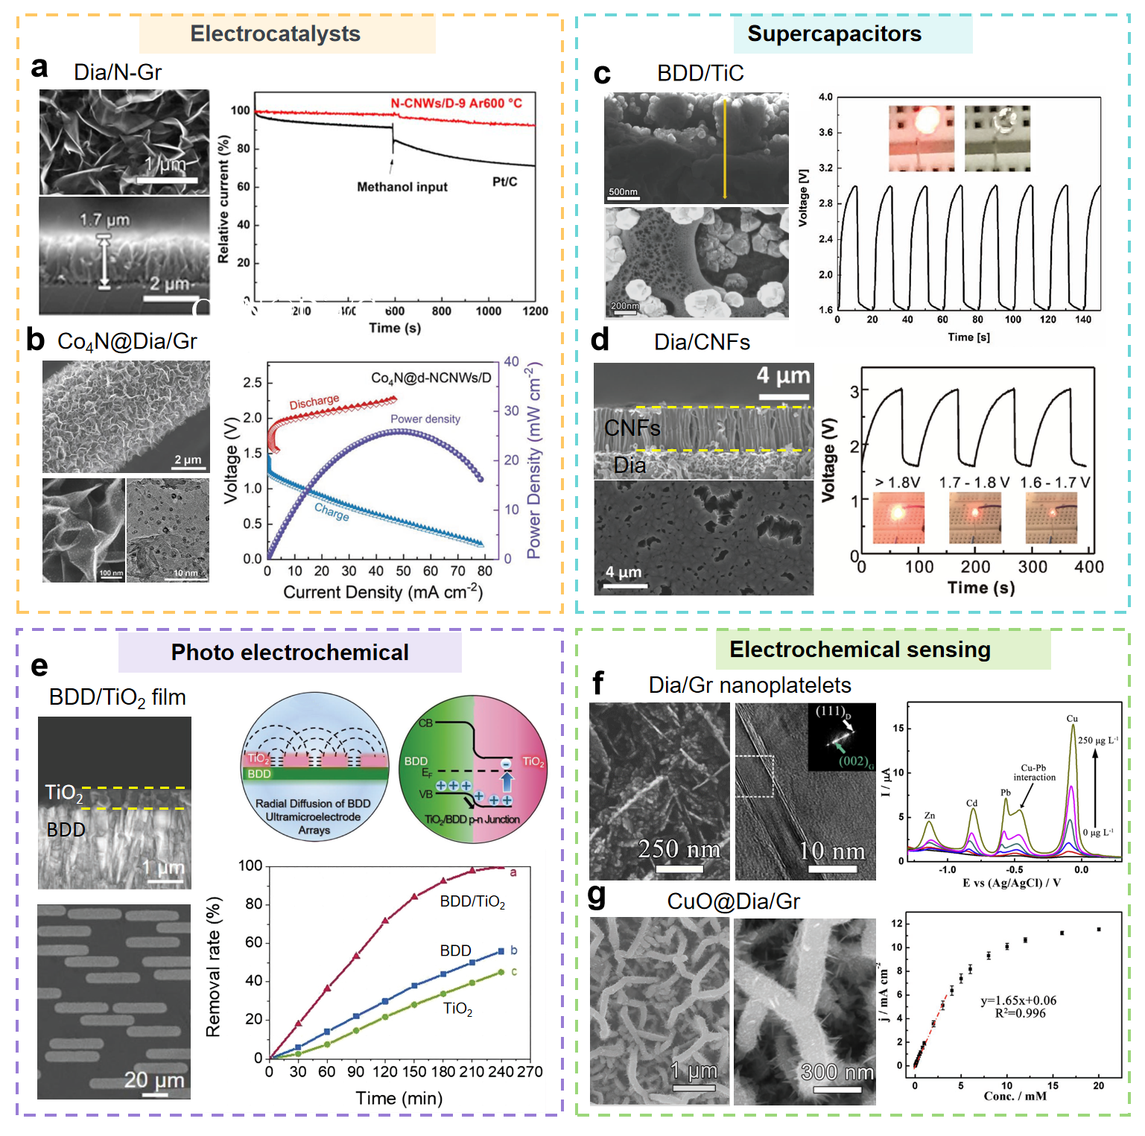
Figure 7. Electrochemical applications of DCs: (a) Top and cross-sectional SEM images of a N-Gr/Dia composite and schematic illustration of its enhanced ORR performance.²⁰ Reproduced with permission from ref 20. Copyright 2021 IOP Publishing. (b) SEM and TEM images of a Co₄N@Gr/Dia composite and electrochemical performance of flexible zinc-air batteries assembled using this composite.¹⁸ Reproduced with permission from ref 18. Copyright 2023 Wiley-VCH. (c,d) Top and cross-sectional SEM images of (c) a BDD/TiC composite and (d) a CNF/BDD composite as well as their performance as supercapacitor electrodes.^{13,14} Reproduced with permission from ref 13 and 14. Copyright 2018, 2019 Wiley-VCH. (e) Top and cross-sectional SEM images, schematic illustration of the photo-electrocatalytic mechanism of a patterned TiO₂/BDD composite, and the comparison of its photoelectrochemical degradation of methyl blue with other electrodes.²¹ Reproduced with permission from ref 21. Copyright 2020 Wiley-VCH. (f) SEM and TEM images of a Dia/Gr composite and its differential pulse anodic stripping voltammogram for the simultaneous determination of Zn(II), Cd(II), Pb(II) and Cu(II) ions.¹⁵ Reproduced with permission from ref 15. Copyright 2018 Elsevier. (g) SEM images of a CuO@Gr/Dia composite and its corresponding calibration curve for non-enzymatic detection of glucose.²³ Reproduced with permission from ref 23. Copyright 2019 Wiley-VCH.

3.3.3 Photoelectrochemistry
Some DCs have been explored as the photoelectrodes for photo electrochemistry. A standard approach of utilizing a DC in photoelectrochemical applications involves the formation of a p-n composite or a heterojunction. The typical example is to combine a p-type semiconductor (e.g., BDD) with a n-type semiconductor (e.g., TiO₂).²¹ To adjust the photo-electrocatalytic abilities of this heterojunction, the exposure ratio of the BDD patterns on this heterojunction was varied. This is because the p-n heterojunction enhanced charge carrier separation and prevents recombination of electron-hole pairs (Figure 7e). It completely degraded methyl orange within 4 h, following the application of a 2.5 V bias potential, while the degradation efficiency on the BDD film and the TiO₂ film was 56% and 45%, respectively. As confirmed by electron spin resonance spectroscopy, an accelerated production rate of •OH radicals is realized on this heterojunction. It originates from a synergistic effect between the BDD patterns that act as an ultra-microelectrode array with a TiO₂/BDD p-n heterojunction as well as facilitated charge separation in a lateral direction.

3.3.4 Electroanalysis
Some DCs have been applied as sensing materials for electrochemical detection of different soluble targets (e.g., heavy metal ions, biomolecules). Take Dia/Gr composites as an example, they exhibited higher sensitivity, wider linear ranges, more facile R_{ct} values and larger active areas than a BDD film. Therefore, these electrodes presented lower detection limits (LODs), wider linear ranges, better reproducibility, enhanced stability, and higher selectivity toward monitoring heavy metals ions (e.g., Ag⁺, Zn²⁺, Cd²⁺, Pb²⁺ and Cu²⁺).^{15,16.23} The Dia/Gr composite exhibited superior performance toward simultaneous detection of Zn²⁺, Cd²⁺, Pb²⁺ and Cu²⁺ ions, including wide linear ranges (e.g., from 10 to 250 μg L⁻¹) and low LODs (Figure 7f).¹⁵ The rationally designed 3D-networked CuO@Gr/Dia composite was applied for the non-enzymatic detection of glucose, delivering a wide linear range, high sensitivity, and a low LOD, high selectivity, great long-term stability, and good reproducibility. The performance of this DC electrode was ascribed to the synergistic effect from highly electrocatalytic CuO nanoparticles and the 3D-networked conductive Dia/Gr composite (Figure 7g). As an excellent transducer, this composite was believed to greatly accelerate the mass- and charge-transport kinetics of electrocatalytic reaction on the CuO biorecognition element.²³

4. Summary and outlook
The artificial integration of component(s) into diamond films, named as diamond composites (DCs) in this Account, is an appealing tactic for producing advanced and versatile materials. These DCs are intricately designed during diamond film and composite CVD growth processes, as well as through subsequent treatments. Manipulating growth conditions during the CVD processes allows these DCs to manifest diverse crystalline orientations and phase concentrations. The structures and properties of DCs are further dependent on the introduced composite counterparts. Consequently, the design and structure of DCs composites can be tailored to achieve specific properties. By controlling the composition, ratio, and arrangement of materials, can create composites with desired characteristics that neither individual component possesses alone. The microstructure and distribution of phases in the composite also play a vital role. A well-engineered microstructure, with a controlled distribution of components, can lead to optimized properties. For example, a uniformly distributed second phase within the diamond matrix can modify its properties. When combined, these properties may complement each other, resulting in a material that exhibits a combination of desirable traits, such as adjustable thermal expansion coefficients, hardness, adhesion, and photo/electrochemical traits, rendering them highly promising across mechanical engineering, chemistry, and biomedicine applications. In these regards, this Account provides an overview of varied synthesis methods for several DCs and their unique features. Their applications span nanoindentation testing, electrocatalysis for ORR/OER, zinc-air batteries, diamond supercapacitors, photo/electrochemistry, electrochemical sensing, and selective protein adsorption.
Despite significant progress in employing the "1+1>2" strategy to design and synthesize diverse DCs, challenges persist in developing cost-effective and reproducible synthesis approaches. Advancements are crucial in refining growth control techniques to adjust morphologies, crystallinities, grain sizes, and surface areas of DCs.
In addition to novel synthesis methods, characterization of various DCs, especially their atomic phase structures need to be conducted using state-of-the-art in situ and ex situ techniques such as in situ electrochemical Raman, infrared, and impedance spectroscopy. Especially, understanding diamond phase interactions with introduced components, including potential chemical bond formations, requires detailed elucidation through spectroscopic methods. Further enhancement of interactions is imperative to expand the functional capacities of novel DCs. Leveraging transition-metal dichalcogenides, transition metal nitrides, single atom catalysts, alloys, covalent/metal-organic frameworks, and conductive polymers as composite counterparts is pivotal. For example, although sp²-C materials (e.g., graphene) have been synthesized on diamond surfaces, composites with distinct carbon hybridization states promise superior properties. The exploration into synthesizing diamond composites that involve sp³-C diamond and sp-C diamond like graphdiyne holds profound significance (e.g., graphdiyne^{56,57}). All these combinations are anticipated to create synergistic effects, augmenting innovative DC performance.
With respect to the DC applications, they must be extended beyond the mentioned fields-into wear-resistant coatings for extreme environments, various electronic/optoelectronic devices, electrochemical energy storage (e.g., multivalent ion supercapacitors, hybrid batteries), flexible/wearable electronics, and nanopore sequencing-will unravel new research avenues. The biomedicine applications of different DCs need to be further triggered. Although DCs have garnered interest in the biomedical community and some potential applications (e.g., biocompatible coatings, drug delivery systems, biosensing) have been demonstrated, continuous efforts are required to address some important issues of various DCs such as their biodegradation as well as to explore and enhance their performance in various biomedical community.
In conclusion, the continuous growth of DC design, synthesis, and applications using the "1+1>2" strategy will persist, captivating scientists and contributing extensively to diamond-related disciplines, owing to the unparalleled properties and versatility of DCs.

Xinyue Chen obtained her master’s degree from Wuhan Institute of Technology (Wuhan, China) in 2020. Currently, she is a PhD candidate at the University of Siegen (Siegen, Germany) under the supervision of Prof. Xin Jiang and Prof. Nianjun Yang (Hasselt University, Belgium). Her current research interests cover the synthesis of nanomaterials and their application in the field of energy conversion.

Ximan Dong received her M.S. degree from Tianjin University (Tianjin, China) in 2021. She is currently a Ph.D. candidate at the University of Siegen (Siegen, Germany) under the supervision of Prof. Xin Jiang and Prof. Nianjun Yang (Hasselt University, Belgium). Her research focuses on the design of photo-electrochemical materials and their applications in electrochemical energy storage.

Dr. Xin Jiang has been a professor and the chair of Surface and Materials Technology at the University of Siegen (Siegen, Germany) since 2003. He received the award “State Specially Recruited Expert’ of China in 2013. He was a Changjiang-Visiting Chair Professor at Dalian University and Science and Technology, China. His current research fields cover the growth and applications of diamond thin films, nanomaterials and materials characterization.

Dr. Nianjun Yang has been a Professor of Electrochemistry and Catalysis at the Department of Chemistry and Institute of Materials Research (IMO-IMOEC) of Hasselt University (Belgium) since March 2023. His Habilitation in the fields of Materials Science and Surface Engineering finished in 2020 at the University of Siegen. He works on the design, growth, and electrochemical applications of various functional materials.

Acknowledgements
X.C. thanks the China Scholarship Council (CSC) for the financial support (No. 202008420219). X.D. thanks the CSC for the financial support (No. 202106250006). N.Y. thanks the financial support from the Deutsche Forschungsgemeinschaft (DFG, German Research Foundation) under the Project No. 457444676.

References
(1) Yang, N.; Yu, S.; Macpherson, J. V.; Einaga, Y.; Zhao, H.; Zhao, G.; Swain, G. M.; Jiang, X. Conductive Diamond: Synthesis, Properties, and Electrochemical Applications. Chem. Soc. Rev. 2019, 48 (1), 157–204. https://doi.org/10.1039/C7CS00757D.
(2) Tang, H.; Yuan, X.; Cheng, Y.; Fei, H.; Liu, F.; Liang, T.; Zeng, Z.; Ishii, T.; Wang, M.-S.; Katsura, T.; Sheng, H.; Gou, H. Synthesis of Paracrystalline Diamond. Nature 2021, 599 (7886), 605–610. https://doi.org/10.1038/s41586-021-04122-w.
(3) Yang, N.; Yu, S.; Zhang, W.; Cheng, H.-M.; Simon, P.; Jiang, X. Electrochemical Capacitors with Confined Redox Electrolytes and Porous Electrodes. Adv. Mater. 2022, 34 (34), 2202380. https://doi.org/10.1002/adma.202202380.
(4) Zeng, Z.; Wen, J.; Lou, H.; Zhang, X.; Yang, L.; Tan, L.; Cheng, B.; Zuo, X.; Yang, W.; Mao, W. L.; Mao, H.; Zeng, Q. Preservation of High-Pressure Volatiles in Nanostructured Diamond Capsules. Nature 2022, 608 (7923), 513–517. https://doi.org/10.1038/s41586-022-04955-z.
(5) Yang, N.; Foord, J. S.; Jiang, X. Diamond Electrochemistry at the Nanoscale: A Review. Carbon 2016, 99, 90–110. https://doi.org/10.1016/j.carbon.2015.11.061.
(6) Yu, S.; Yang, N.; Liu, S.; Jiang, X. Diamond Supercapacitors: Progress and Perspectives. Curr. Opin. Solid State Mater. Sci. 2021, 25 (3), 100922. https://doi.org/10.1016/j.cossms.2021.100922.
(7) Jiang, X.; Klages, C.-P. Synthesis of Diamond/β-SiC Composite Films by Microwave Plasma Assisted Chemical Vapor Deposition. Appl. Phys. Lett. 1992, 61 (14), 1629–1631. https://doi.org/10.1063/1.108458.
(8) Zhuang, H. Controlled Wettability of Diamond/β-SiC Composite Thin Films for Biosensoric Applications. J Phys Chem C 2010. 114, 20207–20212 https://doi.org/10.1021/jp109093h.
(9) Zhuang, H.; Zhang, L.; Staedler, T.; Jiang, X. Highly Selective Diamond and β-SiC Crystal Formation at Increased Atomic Hydrogen Concentration: A Route for Synthesis of High-Quality and Patterned Hybrid Diamond/β-SiC Composite Film. Scr. Mater. 2011, 65 (6), 548–551. https://doi.org/10.1016/j.scriptamat.2011.06.023.
(10) Zhuang, H.; Zhang, L.; Staedler, T.; Jiang, X. Nanoscale Integration of SiC/SiO₂ Core-Shell Nanocables in Diamond through a Simultaneous Hybrid Structure Fabrication. Appl. Phys. Lett. 2012, 100 (19), 193102. https://doi.org/10.1063/1.4712044.
(11) Zhuang, H.; Jiang, X. Growth Controlling of Diamond and β-SiC Microcrystals in the Diamond/β-SiC Composite Films. Surf. Coat. Technol. 2014, 249, 84–89. https://doi.org/10.1016/j.surfcoat.2014.03.053.
(12) Yu, S.; Yang, N.; Zhuang, H.; Meyer, J.; Mandal, S.; Williams, O. A.; Lilge, I.; Schönherr, H.; Jiang, X. Electrochemical Supercapacitors from Diamond. J. Phys. Chem. C 2015, 119 (33), 18918–18926. https://doi.org/10.1021/acs.jpcc.5b04719.
(13) Yu, S.; Yang, N.; Vogel, M.; Mandal, S.; Williams, O. A.; Jiang, S.; Schönherr, H.; Yang, B.; Jiang, X. Battery-like Supercapacitors from Vertically Aligned Carbon Nanofiber Coated Diamond: Design and Demonstrator. Adv. Energy Mater. 2018, 8 (12), 1702947. https://doi.org/10.1002/aenm.201702947.
(14) Xu, J.; Yang, N.; Heuser, S.; Yu, S.; Schulte, A.; Schönherr, H.; Jiang, X. Achieving Ultrahigh Energy Densities of Supercapacitors with Porous Titanium Carbide/Boron-Doped Diamond Composite Electrodes. Adv. Energy Mater. 2019, 9 (17), 1803623. https://doi.org/10.1002/aenm.201803623.
(15) Zhai, Z.; Huang, N.; Zhuang, H.; Liu, L.; Yang, B.; Wang, C.; Gai, Z.; Guo, F.; Li, Z.; Jiang, X. A Diamond/Graphite Nanoplatelets Electrode for Anodic Stripping Voltammetric Trace Determination of Zn(II), Cd(II), Pb(II) and Cu(II). Appl. Surf. Sci. 2018, 457, 1192–1201. https://doi.org/10.1016/j.apsusc.2018.06.266.
(16) Guo, Y.; Huang, N.; Yang, B.; Wang, C.; Zhuang, H.; Tian, Q.; Zhai, Z.; Liu, L.; Jiang, X. Hybrid Diamond/Graphite Films as Electrodes for Anodic Stripping Voltammetry of Trace Ag⁺ and Cu²⁺. Sens. Actuators B Chem. 2016, 231, 194–202. https://doi.org/10.1016/j.snb.2016.02.098.
(17) Tian, Q.; Yang, B.; Zhuang, H.; Guo, Y.; Wang, C.; Zhai, Z.; Liu, L.; Huang, N.; Jiang, X. Hybrid Diamond/Graphite Films: Morphological Evolution, Microstructure and Tribological Properties. Diam. Relat. Mater. 2016, 70, 179–185. https://doi.org/10.1016/j.diamond.2016.10.020.
(18) Zhang, C.; Huang, N.; Zhai, Z.; Liu, L.; Chen, B.; Yang, B.; Jiang, X.; Yang, N. Bifunctional Oxygen Electrocatalyst of Co₄N and Nitrogen-Doped Carbon Nanowalls/Diamond for High-Performance Flexible Zinc–Air Batteries. Adv. Energy Mater. 2023, 13 (41), 2301749. https://doi.org/10.1002/aenm.202301749.
(19) Zhai, Z.; Huang, N.; Yang, B.; Liu, L.; Li, H.; Chen, J.; Zhang, B.; Jiang, X. In Situ Construction of Hierarchical Diamond Supported on Carbon Nanowalls/Diamond for Enhanced Electron Field Emission. ACS Appl. Mater. Interfaces 2020, 12 (7), 8522–8532. https://doi.org/10.1021/acsami.9b18004.
(20) Zhang, C.; Huang, N.; Zhai, Z.; Liu, L.; Chen, B.; Lu, Z.; Zhou, M.; Song, H.; Shi, D.; Yang, B.; Yang, N.; Jiang, X. Nitrogen-Doped Carbon Nanowalls/Diamond Films as Efficient Electrocatalysts toward Oxygen Reduction Reaction. Nanotechnology 2021, 33 (1), 015401. https://doi.org/10.1088/1361-6528/ac2a84.
(21) Jian, Z.; Yang, N.; Vogel, M.; Zhou, Z.; Zhao, G.; Kienitz, P.; Schulte, A.; Schönherr, H.; Jiao, T.; Zhang, W.; Jiang, X. Tunable Photo-Electrochemistry of Patterned TiO₂/BDD Heterojunctions. Small Methods 2020, 4 (9), 2000257. https://doi.org/10.1002/smtd.202000257.
(22) Chen, B.; Zhai, Z.; Huang, N.; Zhang, C.; Yu, S.; Liu, L.; Yang, B.; Jiang, X.; Yang, N. Highly Localized Charges of Confined Electrical Double-Layers Inside 0.7-nm Layered Channels. Adv. Energy Mater. 2023, 13 (36), 2300716. https://doi.org/10.1002/aenm.202300716.
(23) Zhai, Z.; Leng, B.; Yang, N.; Yang, B.; Liu, L.; Huang, N.; Jiang, X. Rational Construction of 3D-Networked Carbon Nanowalls/Diamond Supporting CuO Architecture for High-Performance Electrochemical Biosensors. Small 2019, 15 (48), 1901527. https://doi.org/10.1002/smll.201901527.
(24) Deshmukh, S.; Kunuku, S.; Jakobczyk, P.; Olejnik, A.; Chen, C.-H.; Niu, H.; Yang, B.; Yang, N.; Bogdanowicz, R. Diamond-Based Supercapacitors with Ultrahigh Cyclic Stability Through Dual-Phase MnO₂-Graphitic Transformation Induced by High-Dose Mn-Ion Implantation. Adv. Funct. Mater. 2023, https://doi.org/10.1002/adfm.202308617.
(25) Srikanth Vadali, V. S. S.; Samra, H. A.; Staedler, T.; Jiang, X. Nanocrystalline Diamond/β-SiC Composite Interlayers for the Deposition of Continuous Diamond Films on W and Mo Substrate Materials. Surf. Coat. Technol. 2007, 201 (22), 8981–8985. https://doi.org/10.1016/j.surfcoat.2007.04.018.
(26) Tian, Q.; Huang, N.; Yang, B.; Zhuang, H.; Wang, C.; Zhai, Z.; Li, J.; Jia, X.; Liu, L.; Jiang, X. Diamond/β-SiC Film as Adhesion-Enhanced Interlayer for Top Diamond Coatings on Cemented Tungsten Carbide Substrate. J. Mater. Sci. Technol. 2017, 33 (10), 1097–1106. https://doi.org/10.1016/j.jmst.2017.06.005.
(27) Yu, S.; Sankaran, K. J.; Korneychuk, S.; Verbeeck, J.; Haenen, K.; Jiang, X.; Yang, N. High-Performance Supercabatteries Using Graphite@diamond Nano-Needle Capacitor Electrodes and Redox Electrolytes. Nanoscale 2019, 11 (38), 17939–17946. https://doi.org/10.1039/C9NR07037K.
(28) Wang, T.; Handschuh-Wang, S.; Yang, Y.; Zhuang, H.; Schlemper, C.; Wesner, D.; Schönherr, H.; Zhang, W.; Jiang, X. Controlled Surface Chemistry of Diamond/β-SiC Composite Films for Preferential Protein Adsorption. Langmuir 2014, 30 (4), 1089–1099. https://doi.org/10.1021/la404277p.
(29) Wang, T.; Handschuh-Wang, S.; Huang, L.; Zhang, L.; Jiang, X.; Kong, T.; Zhang, W.; Lee, C.-S.; Zhou, X.; Tang, Y. Controlling Directional Liquid Motion on Micro- and Nanocrystalline Diamond/β-SiC Composite Gradient Films. Langmuir 2018, 34 (4), 1419–1428. https://doi.org/10.1021/acs.langmuir.7b04072.
(30) Yang, B.; Li, J.; Guo, L.; Huang, N.; Liu, L.; Zhai, Z.; Long, W.; Jiang, X. Fabrication of Silicon-Vacancy Color Centers in Diamond Films: Tetramethylsilane as a New Dopant Source. CrystEngComm 2018, 20 (8), 1158–1167. https://doi.org/10.1039/C7CE02181J.
(31) Guo, Y.; Staedler, T.; Fu, H.; Heuser, S.; Jiang, X. A Novel Way to Quantitatively Determine the Mechanical Properties of Thin Films from the Initial-Grown Surface by Nanoindentation. Appl. Surf. Sci. 2019, 479, 253–259. https://doi.org/10.1016/j.apsusc.2019.02.075.
(32) Bundy, F. P.; Hall, H. T.; Strong, H. M.; Wentorfjun., R. H. Man-Made Diamonds. Nature 1955, 176 (4471), 51–55. https://doi.org/10.1038/176051a0.
(33) Matsumoto, S.; Sato, Y.; Tsutsumi, M.; Setaka, N. Growth of Diamond Particles from Methane-Hydrogen Gas. J. Mater. Sci. 1982, 17 (11), 3106–3112. https://doi.org/10.1007/BF01203472.
(34) Zhai, Z.; Huang, N.; Yang, B.; Wang, C.; Liu, L.; Qiu, J.; Shi, D.; Yuan, Z.; Lu, Z.; Song, H.; Zhou, M.; Chen, B.; Jiang, X. Insight into the Effect of the Core–Shell Microstructure on the Electrochemical Properties of Undoped 3D-Networked Conductive Diamond/Graphite. J. Phys. Chem. C 2019, 123 (10), 6018–6029. https://doi.org/10.1021/acs.jpcc.8b11865.
(35) Jiang, X.; Zhuang, H. Diamond/β-SiC Composite Thin Films: Preparation, properties and applications. In Novel Aspects of Diamond: From Growth to Applications, Yang, N. E.d.; Cham: Springer International Publishing, 2015; pp 31–52. https://doi.org/10.1007/978-3-319-09834-0_2.
(36) Shpilevaya, I.; Smirnov, W.; Hirsz, S.; Yang, N.; Nebel, C. E.; Foord, J. S. Nanostructured Diamond Decorated with Pt Particles: Preparation and Electrochemistry. RSC Adv. 2013, 4 (2), 531–537. https://doi.org/10.1039/C3RA43763A.
(37) Jiang, X,; Zhuang, H.; Fu, H. Diamond/β-SiC Composite Films. In Novel Carbon Materials and Composites: Synthesis, Properties and Applications; Jiang, X., Kang, Z., Guo, X., Zhuang, H., Eds. John Wiley & Sons, 2019; pp 169–203. https://doi.org/10.1002/9781119313649.ch6.
(38) Srikanth, V. V. S. S.; Staedler, T.; Jiang, X. Deposition of Stress-Free Diamond Films on Si by Diamond/β-SiC Nanocomposite Intermediate Layers. Diam. Relat. Mater. 2009, 18 (10), 1326–1331. https://doi.org/10.1016/j.diamond.2009.07.007.
(39) Yokoya, T.; Nakamura, T.; Matsushita, T.; Muro, T.; Takano, Y.; Nagao, M.; Takenouchi, T.; Kawarada, H.; Oguchi, T. Origin of the Metallic Properties of Heavily Boron-Doped Superconducting Diamond. Nature 2005, 438 (7068), 647–650. https://doi.org/10.1038/nature04278.
(40) Kim, K. J.; Lim, K.-Y.; Kim, Y.-W.; Kim, H. C. Temperature Dependence of Electrical Resistivity (4–300 K) in Aluminum- and Boron-Doped SiC Ceramics. J. Am. Ceram. Soc. 2013, 96 (8), 2525–2530. https://doi.org/10.1111/jace.12351.
(41) Fu, H.; Zhuang, H.; Yang, L.; Hantschel, T.; Ma, S.; Zhang, Z.; Jiang, X. Synthesis and Characterization of Boron Doped Diamond/β-SiC Composite Films. Appl. Phys. Lett. 2017, 110 (3), 031601. https://doi.org/10.1063/1.4974295.
(42) Guo, Y.; Staedler, T.; Müller, J.; Heuser, S.; Butz, B.; Jiang, X. A Detailed Analysis of the Determination of Fracture Toughness by Nanoindentation Induced Radial Cracks. J. Eur. Ceram. Soc. 2020, 40 (2), 276–289. https://doi.org/10.1016/j.jeurceramsoc.2019.10.013.
(43) Wang, T.; Zhuang, H.; Jiang, X. One Step Deposition of Highly Adhesive Diamond Films on Cemented Carbide Substrates via Diamond/β-SiC Composite Interlayers. Appl. Surf. Sci. 2015, 359, 790–796. https://doi.org/10.1016/j.apsusc.2015.10.165.
(44) Srikanth, V. V. S. S.; Jiang, X.; Köpf, A. Deposition of Diamond/β-SiC Nanocomposite Films onto a Cutting Tool Material. Surf. Coat. Technol. 2010, 204 (15), 2362–2367. https://doi.org/10.1016/j.surfcoat.2010.01.008.
(45) Wang, T.; Xiang, L.; Shi, W.; Jiang, X. Deposition of Diamond/β-SiC/Cobalt Silicide Composite Interlayers to Improve Adhesion of Diamond Coating on WC–Co Substrates by DC-Plasma Assisted HFCVD. Surf. Coat. Technol. 2011, 205 (8), 3027–3034. https://doi.org/10.1016/j.surfcoat.2010.11.014.
(46) Roach, P.; Farrar, D.; Perry, C. C. Interpretation of Protein Adsorption: Surface-Induced Conformational Changes. J. Am. Chem. Soc. 2005, 127 (22), 8168–8173. https://doi.org/10.1021/ja042898o.
(47) Shovsky, A.; Schönherr, H. New Combinatorial Approach for the Investigation of Kinetics and Temperature Dependence of Surface Reactions in Thin Organic Films. Langmuir 2005, 21 (10), 4393–4399. https://doi.org/10.1021/la046967o.
(48) Yang, N.; Jiang, X. Rational Design of Diamond Electrodes. Acc. Chem. Res. 2023, 56 (2), 117–127. https://doi.org/10.1021/acs.accounts.2c00644.
(49) Zalieckas, J.; Mondragon, I. R.; Pobedinskas, P.; Kristoffersen, A. S.; Mohamed-Ahmed, S.; Gjerde, C.; Høl, P. J.; Hallan, G.; Furnes, O. N.; Cimpan, M. R.; Haenen, K.; Holst, B.; Greve, M. M. Polycrystalline Diamond Coating on Orthopedic Implants: Realization and Role of Surface Topology and Chemistry in Adsorption of Proteins and Cell Proliferation. ACS Appl. Mater. Interfaces 2022, 14 (39), 44933–44946. https://doi.org/10.1021/acsami.2c10121.
(50) Nebel, C. E.; Rezek, B.; Shin, D.; Uetsuka, H.; Yang, N. Diamond for bio-sensor applications. J. Phys. D: Appl. Phys. 2007, 40(20), 6443. https://doi.org/10.1088/0022-3727/40/20/S21.
(51) Van Oss, C. J.; Chaudhury, M. K.; Good, R. J. Interfacial Lifshitz-van Der Waals and Polar Interactions in Macroscopic Systems. Chem. Rev. 1988, 88 (6), 927–941. https://doi.org/10.1021/cr00088a006.
(52) Panizza, M.; Cerisola, G. Application of Diamond Electrodes to Electrochemical Processes. Electrochimica Acta 2005, 51 (2), 191–199. https://doi.org/10.1016/j.electacta.2005.04.023.
(53) Jian, Z.; Heide, M.; Yang, N.; Engelhard, C.; Jiang, X. Diamond Fibers for Efficient Electrocatalytic Degradation of Environmental Pollutants. Carbon 2021, 175, 36–42. https://doi.org/10.1016/j.carbon.2020.12.066.
(54) Rao, T. N.; Fujishima, A. Recent Advances in Electrochemistry of Diamond. Diam. Relat. Mater. 2000, 9 (3), 384–389. https://doi.org/10.1016/S0925-9635(99)00234-4.
(55) Guo, T.; Yang, N.; Yang, B.; Schulte, A.; Jin, Q.; Koch, U.; Mandal, S.; Engelhard, C.; Williams, O. A.; Schönherr, H.; Jiang, X. Electrochemistry of Nitrogen and Boron Bi-Element Incorporated Diamond Films. Carbon 2021, 178, 19–25. https://doi.org/10.1016/j.carbon.2021.02.062.
(56) Wang, M.; Pu, J.; Hu, Y.; Zi, Y.; Wu, Z.-G.; Huang, W. Functional Graphdiyne for Emerging Applications: Recent Advances and Future Challenges. Adv. Funct. Mater. 2023, 2308601. https://doi.org/10.1002/adfm.202308601.
(57) Chen, X.; Jiang, X.; Yang, N. Graphdiyne Electrochemistry: Progress and Perspectives. Small 2022, 18 (24), 2201135. https://doi.org/10.1002/smll.202201135.

This page for Table of Contents use only

Diamond Composite: A “1+1 >2” Strategy to Design and Explore Advanced Functional Materials

Xinyue Chen^{a†}, Ximan Dong^{a†}, Xin Jiangª, and Nianjun Yang^{b*}

