Carrier lifetime, diffusion length and mobility in (100) CVD diamond samples pre-treated in an O₂/H₂-plasma

W. Deferme¹, K. Haenen^{1,2}, M. Nesládek^{1,2}, T. Malinauskas³, L. Lubys³, K. Jarašiūnas³

¹Hasselt University, Institute for Materials Research (IMO), Diepenbeek, Belgium
²IMEC vzw, Division IMOMEC, Diepenbeek, Belgium
³Vilnius University, Institute of Applied Research, Vilnius, Lithuania

ABSTRACT

In this article, (100) Ib diamond substrates are pre-treated for different durations in an O₂/H₂-plasma, influencing the etching of defects like unepitaxial crystals, flat top hillocks, and pyramidal hillocks [1-3]. Such procedure is used to prevent those to incorporate into the ~ 100μm thick CVD diamond film, which is subsequently grown on top. While the surface morphology and structure of substrates and films are studied by SEM, the time-resolved Light-Induced Transient Grating (LITG) technique provides information on the excess carrier parameters close to the front surface of the grown layers. This technique is particularly useful as it does not requires a separation of the CVD film from its substrate. It will be shown that O₂/H₂-plasma treatments of more than 150 minutes but less than 240 minutes largely reduce the incorporation of defects in the bulk of the grown film. This, in turn, influences the carrier dynamics as measured by LITG, but also the surface roughness and growth rate as shown by SEM.

INTRODUCTION

The recent advances in the deposition of high quality homoepitaxial CVD diamond make this material increasingly interesting for device applications [4-6]. An important aspect of the growth is the pursuit of quality improvement of the diamond crystal with its thickness, related to the coalescence of individual growth sectors, and the suppression of the propagation of certain dislocations during the initial stages of growth [7]. Hence, there is a large interest in understanding how the defects (intrinsic and extrinsic) related to these initial stages, influence the charge carrier parameters like mobility and lifetime. To ensure the high efficiency of charge collection, the carrier diffusion length should be as high as possible which can be achieved by reducing the density of electrically active point and extended defects. An etching step prior to the growth step has been shown to be efficient [2,4,7] but it is unclear until now how the duration of this pre-treatment is influencing the removal of defects or the eventual formation of new defects. Therefore it is of great interest to differ the etching time and evaluate the influence of this duration on the electronic properties such as carrier lifetime, diffusion coefficient, mobility and carrier diffusion length [8,9]. The time-resolved light-induced transient grating technique, used in this work, has already shown its great potential for other materials such as doped CdTe and GaN [10,11]. As no contacts are needed on the sample under study and no lift-off from the substrate is required this technique is also very promising for thick diamond layers grown on Ib (100) oriented diamond substrates.

EXPERIMENT

Samples

Single crystal Ib (100) oriented diamond substrates are exposed to a microwave induced plasma in a 2-step process. Prior to this, the diamond substrates are chemically oxidized using an acidic solution of H₂SO₄ and KNO₃ at 250°C for 30 minutes to remove surface contaminants, followed by rinsing in ultra-pure water. The first step of the plasma process is an etching step. A hydrogen plasma containing 4% of oxygen is created at a pressure of 70Torr and a power of 900W. The length of this pre-treatment is varied during the experiments from 30 minutes up to 300 minutes. During the second stage, the growth of a CVD diamond layer on top of these pre-treated samples is performed using a mixture of 6% of methane in a hydrogen plasma at a pressure of 180Torr, a power of 600W and a temperature up to 1100°C. The growth step is performed for 20 hours and is invariant for all samples under study.
A Scanning Electron Microscopy (SEM) study of the layers is performed after the first step (pre-treatment) and after the final step (growth), enabling the study of the surface morphology after the H₂/O₂-treatment and after the growth, as well as the determination of the thickness of the final CVD layer.

Light Induced Transient Grating

The Light Induced Transient Grating (LITG) technique is a method to determine the electronic properties of our single crystalline diamond layers without using electrical contacts. In this way, the influence of contact-formation and the problems that arise at the interface between contact and samples are eliminated. Also, the sample under study doesn’t have to be lifted off from the substrate as is the case for Time-of-Flight (ToF) or other techniques to resolve the electronic properties [8,9,12].
The setup used is depicted in figure 1. The sample is mounted in a closed cycle helium cryostat, which allowes to vary a temperature from 10K up to 300K. The transient grating is recorded by the interference pattern of two coherent laser pulses with a duration of 25ps at 213nm. This creates a periodically modulated nonequilibrium carrier density distribution. The transient diffraction grating is formed in the sample since the injected free carriers change the refractive index of the material under study. The decay of the density modulation is monitored by the diffraction of an optically delayed probe beam at 1064nm.

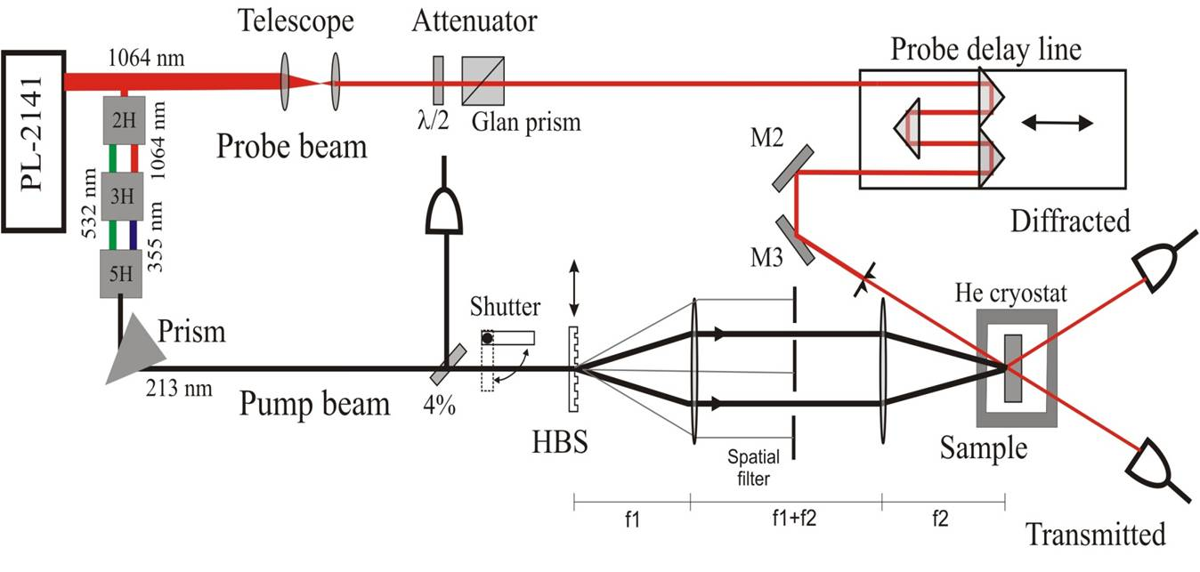
Figure 1. The light induced transient grating setup [11]

At interband excitation, free electron-hole pairs were created within a thin excited layer of thickness d_{eff} ~ α⁻¹ of about 10 μm [13,14]. The grating decay is usually governed by carrier recombination and lateral diffusion, providing the total grating decay rate:

1/τ_{G} = 1/τ_{R} + 1/τ_{D} (1)

where τ_{G} ist the grating decay time, τ_{R} is the carrier lifetime and τ_{D} is the diffusion time. At small grating periods the diffusive decay dominates:

1/τ_{D} = 4π²D_{a}/Λ² (2)

with D_{a} the diffusion coefficient and Λ the grating period.
By measuring grating decay time τ_{G} at several grating periods Λ, the carrier lifetime τ_{R} and the ambipolar carrier diffusion coefficient D_{a} can be determined.

DISCUSSION

Here, a series of 7 samples will be discussed where the etching time varies from 30 minutes for sample A2 up to 300 minutes for sample A7 as is listed up in Table 1. In figure 2 some SEM images of the different samples after the pretreatment are shown. It is clear from these images that on all samples the pre-treatment is etching some parts of the sample. The shape of the etch-pits is depending on the defect which is etched.

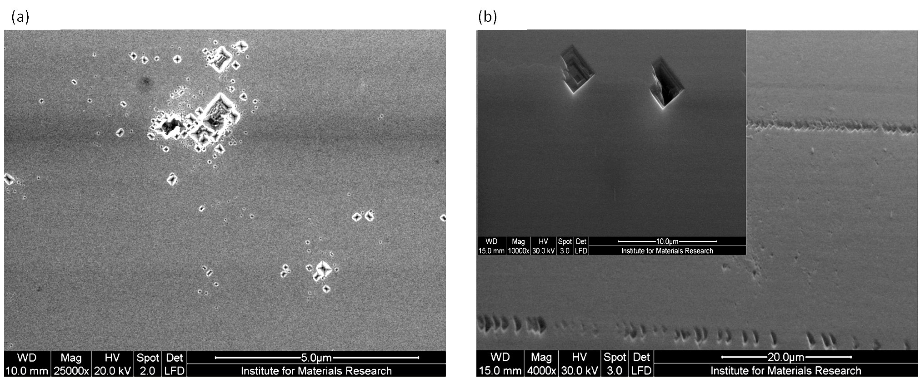
Figure 2. (a) Etch pits resulting from defects such as dislocations, (b) etch pit formed at
the polishing lines of the diamond substrate (inset: structure of these etch pits)

As is shown in figure 2(a) the etch pits look like an inverted pyramid. These etch pits are developed from defects such as dislocations. On the other hand, in figure 2(b) the defects have a flat bottom part and are thought to be developed from defects like dislocations and microfractures induced by polishing [2]. It is clear from the figure that the latter defects are positioned on the polishing lines. For this kind of defects, the etching rate will only be different as long as the depth of the hardened zone is not reached. When the hardened zone has been etched away, the etching rate of the flat bottom part of the defect, which is (100) in our case, will be the same as the etching rate of the overall surface, which is also (100) oriented. The defects shown in figure 2(a) have a different etching rate compared to the overall (100) surface as the sides of the inverted pyramid can be (113) or (111) oriented faces. The rapid filling of these defects will be possible only when strict growth conditions are met [2,3,5]. That is why in some SEM images in figure 3 some inverted pyramidal shapes are still visible. In these figures, the surface of the different samples after the growth step is shown, clearly resolving the smoother surface after etching times between 150 and 240 minutes.

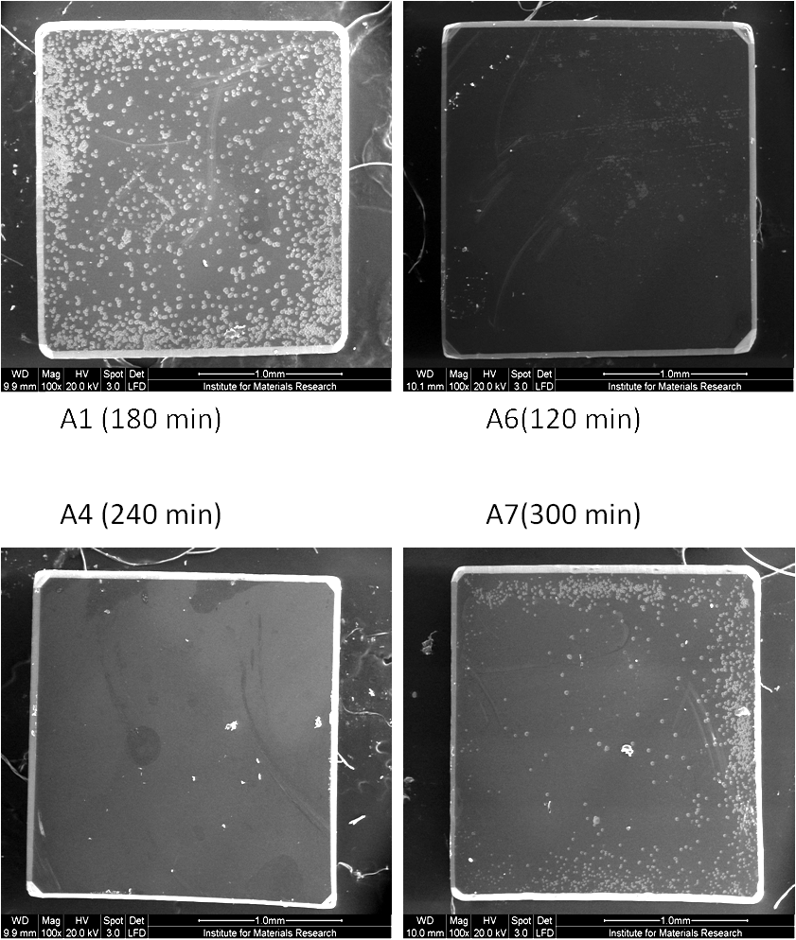
Figure 3. SEM images after a growth step of 20 hours for 4 different pre-treatment
durations showing a clear difference in surface smoothness

If, after growth, the surfaces of the different samples are compared it is already clear that a longer pre-treatment will result in a smoother surface. To clarify how different treatment times affect the electrical properties, the light induced transient grating technique is used. The carrier lifetime is measured by using interband excitation of 213nm with an energy of 1.7mJ/cm², corresponding to an excess carrier density of 2x10¹⁸ cm⁻³. A grating period Λ of 13μm was applied.

Figure 4. Grating decay kinetics for all samples under study at 213nm excitation. The grating decay times are shown in the figure

In figure 4 the decay of diffraction efficiency for the seven samples is plotted. Similarly, the measurement is performed for a few other grating periods (Λ=7 and 4μm). From these measurements, the carrier lifetime τ_{R} and the diffusion coefficient D_{a} were calculated. These results are plotted in figure 5 and summarized in Table 1 showing that the diffusion coefficient is not depending on the sample history, i.e. the pre-treatment time, while the carrier lifetime is strongly influenced by the etching time.

Figure 5. Carrier lifetime values according to the pre-treatment durations

Therefore, carrier lifetime is a good measure of sample quality as dislocations can act as centers of nonradiative recombination. From these experiments it is clear that a short etching time of less than 150 minutes leads to a carrier lifetime of 1ns as is also the case for longer etching times, i.e. more than 240 minutes. An intermediate etching time between 150 and 240 minutes shows an increase of carrier lifetime up to three times.

Table 1. The etching time, growth rate, carrier lifetime and diffusion coefficient for all the samples under study

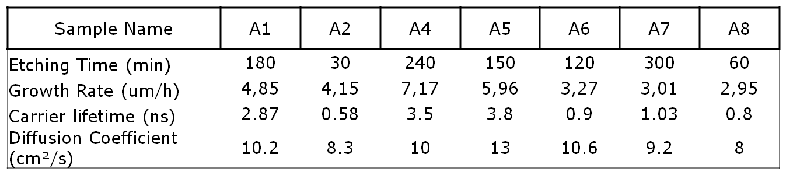

Comparing these results with the data in Table 1 it is clear that the growth rate, the surface morphology and the carrier lifetime are linked in such a way that the samples which are pretreated for a short time are not completely defect-free such that these defects will extent into the layer during growth. It also appears that the sample that underwent a plasma pre-treatment of more than 240 minutes shows again a lower carrier lifetime and a slower growth rate, which would illustrate that a prolonged etching time results in the creation of “new” defects though this point needs further study.

CONCLUSIONS

(100) single crystal diamond samples are grown in two steps where the first step consists out of a pre-treatment of the substrate surface in a hydrogen plasma containing 4% of oxygen for different durations. In the second step a 20 hour growth is performed on all samples. From SEM measurements it is clear that two kinds of defects are present, all evolving from dislocations, naturally present or polishing induced, at the diamond (sub-) surface. Light induced transient grating is used to determine the carrier lifetime and diffusion coefficient. The diffusion coefficient of around 9cm²/s is measured for all samples under study while a carrier lifetime of 1ns is found for all samples pretreated for a short time (less than 150 minutes) and for a very long time (longer than 240 minutes). The carrier lifetime after a pretreatment at intermediate durations (150 – 240 minutes) reaches 3ns. From these results a carrier diffusion length up to 2.2μm is calculated for the optimal etching times. The combination of the SEM measurements and the LITG technique resolves that an etching time of around 200 minutes is perfect as the first step to diminish the defect concentration in the grown layers, which is a prerequisite to obtain state-of-the-art thick single crystal diamond layers.

ACKNOWLEDGMENTS

This work was financially supported by the Research Program G.0555.10N of the Research Foundation – Flanders (FWO), the IAP-P6/42 project ‘Quantum Effects in Clusters and Nanowires’, the Methusalem network ‘NANO’, and the FP7 projects DINAMO [245122] and MATCON (PITN-GA-2009-238201). WD is a postdoctoral fellow of the Special Research Fund of the UHasselt. At Vilnius University, support was provided by Eureka project No. E!4473.

REFERENCES

1 A. Tallaire, M. Kasu, K. Ueda and T. Makimoto, Diamond Rel. Mater. 17 (2008), 60
2 J. Achard, F. Silva, O. Brinza, X. Bonnin, V. Mille, R. Issaoui, M. Kasu and A. Gicquel, phys. stat. sol. (a) 206/9 (2009), 1949
3 F. Silva, J.Achard, X. Bonnin, A. Michau, A. Tallaire, O. Brinza and A. Gicquel, phys. stat. sol. (a) 203 (2006), 3049
4 G. Bogdan, M. Nesládek, J. D’Haen, J. Maes, V.V. Moshchalkov, K. Haenen and M. D’Olieslaeger, phys. stat. sol. (a) 202/11 (2005), 2066
5 F. Silva, J. Achard, X. Bonnin, O. Brinza, A. Michau, A. Secroun, K. De Corte, S. Felton, M. Newton and A. Gicquel, Diamond Rel. Mater. 17 (2008), 1067
6 T. Teraji, M. Hamada, H. Wada, M. Yamamoto, T. Ito, Diamond Rel. Mater. 14 (2005), 1747
7 A. Tallaire, J. Achard, F. Silva, R.S. Sussmann, A. Gicquel and E. Rzepka, phys. stat. sol. (a) 201 (2004), 2419
8 T. Malinauskas, K. Jarasiunas, E. Ivakin, V. Ralchenko, A. Gontar and S. Ivakhnenko, Diamond Rel. Mater. 17 (2008), 1212
9 T. Malinauskas, K. Jarasiunas, E. Ivakin, N. Tranchant and M. Nesladek, phys. stat. sol. (a), 207 (2010), 2058
10 A. Kadys, M. Sudzius, K. Jarasiunas, O. Fochuk, O. Feychuk, M.L. Hellin and D. Verstraeten, phys. stat. sol. (b) 244 (2007), 1675
11 T. Malinauskas, R. Aleksiejunas, K. Jarasiunas, B. Beaumont, P. Gibart, A. Kakanakova-Georgieva, E. Janzen, D. Gogova, B. Monemar and M. Heuken, Journal of Crystal Growth 300 (2007), 223
12 W. Deferme, A. Bogdan, G. Bogdan, K. Haenen, W. De Ceuninck, M. Nesládek, phys. stat. sol. (a) 204/9 (2007), 3017
13 J. Isberg, J. Hammersberg, D.J. Twitchen and A.J Whitehead, Diamond Rel. Mater. 13 (2004), 320
14 F. Fujita, Y. Oshiki, J.H. Kaneko, A. Homma, K. Tsuji, K. Meguro, Y. Yamamoto, T. Imai, H. Watanabe, T. Teraji, S. Kawamura and M. Furusaka, Diamond Rel. Mater. 15 (2006), 1921

