Article

Physiological Predictors of a super-sprint Triathlon Performance in junior and U23 Triathletes
Chiel Poffé ¹, Ruben Robberechts ², Peter Hespel ³ , Martijn Kusters ⁴, Sebastian Weber ⁵ and Reinout Van Schuylenbergh ^{6,}*
- REVAL – Rehabilitation Research Center, Faculty of Rehabilitation Sciences, Hasselt University, Wetenschapspark 7, 3590 Diepenbeek (Belgium), chiel.poffe@uhasselt.be
- REVAL – Rehabilitation Research Center, Faculty of Rehabilitation Sciences, Hasselt University, Wetenschapspark 7, 3590 Diepenbeek (Belgium), ruben.robberechts@uhasselt.be
- Exercise Physiology Research Group, Department of Movement Sciences, KU Leuven. Tervuursevest 101, 3001 Leuven (Belgium), peter.hespel@kuleuven.be
- Exercise Physiology Research Group, Department of Movement Sciences, KU Leuven. Tervuursevest 101, 3001 Leuven (Belgium), martijn.kusters@kuleuven.be
- INSCYD GmbH, Salenstein (Switzerland), sebastian@inscyd.com
- Exercise Physiology Research Group, Department of Movement Sciences, KU Leuven. Tervuursevest 101, 3001 Leuven (Belgium), reinout.vanschuylenbergh@kuleuven.be

Abstract: The mixed-team super-sprint triathlon relay (∼300m swimming, ∼6.6km cycling and ∼1.5km running) performed in teams of four athletes, is the newest Olympic triathlon discipline. Until today, no scientific data is available on the specific physiological attributes. Our study aims to predict a super-sprint triathlon performance from physiological exercise testing.
Fourteen national level triathletes performed physiological tests in swimming and running and competed in a super-sprint triathlon. The physiological profile in swimming and running was calculated and applied to predict triathlon performance.
The speed at $\dot{V}$O_{2max_swim} corresponded well to the swimming speed during the triathlon ($∆$0.013 m·s⁻¹, n.s.), whereas the running speed was similar to the running speed at metabolic steady state (MMSS_{run}) ($∆$0.05 m·s⁻¹, n.s.). Stepwise multiple regression analysis selected MMSS_{run} as the primary predictor of triathlon performance (r² = 0.66, p<0.05). The swimming speed at metabolic steady state (MMSS_{swim}) (r² = 0.84, p<0.05) and the amount of work that can be performed above MMSS_{run} (W’_{run}) were also included in the prediction model (r² = 0.91, p<0.05).
Our data indicate that MMSS_{run}, MSS_{swim}, and W’_{run} allow for a precise prediction of a super-sprint triathlon performance. This information can be used to optimize training and pacing strategies.
Keywords: Triathlon performance; super-sprint triathlon; metabolic profile, $\dot{V}$O_{2max}, νLamax

1. Introduction
Triathlon combines swimming, cycling and running in a single event. Competition duration varies from ~20 min for the super-sprint distance to ~8h for the long distance in elite athletes. The sport made its Olympic debut at the 2000 Games in Sydney featuring the the standard (Olympic) distance format comprising a 1,500m swim, 40km bike and a 10km run. During the Olympic Games in Tokyo 2020, the mixed-team relay (MTR) was added for the first time to the Olympic program (World Triathlon, 2023b). This triathlon discipline is performed in teams of 4 athletes, 2 women and 2 men. All four athletes on a team must complete a super-sprint triathlon - ~300m swim, ~6.6km bike and ~1.5km run - before tagging off to a teammate (World Triathlon, 2023a).
Due to the novelty of this event, scientific data concerning the MTR is extremely scarce. Quagliarotti and colleagues published one of the first scientific studies investigating the MTR performances in 6 World championship races in Hamburg (2014-2019) (Quagliarotti et al., 2022). They investigated the impact of each leg and discipline of the MTR on the result at the finish line, thereby providing preliminary insights in the characteristics required for optimal performance. They concluded that optimal performance is achieved by positioning triathletes that are stronger while racing in a group and capable of taking advantage from drafting in legs 1 and 2. Conversely, the last two team members should be strong in non-draft legal conditions as, at this stage of the race, the field has split up into smaller groups. Most determining for overall race performance appeared to be the swimming and cycling performances. Ledanois and colleagues used a similar approach to calculate the probabilities of reaching a victory, a podium, or a top 8 rank in a MTR, according to the position of any of the four athletes during each of the four segments of the race (Ledanois et al., 2023). They showed that the differences between the winner, medallist, finalist, or finisher teams are apparent throughout the race. These differences continually increase until the end of the race. Legs 2 and 3 are preponderant on the outcome of the race, the position obtained by each triathlete, especially in swimming and cycling, greatly influences the final performance of the team. Leg 1 allows to maintain contact with the head of the race, while leg 4 determines the position obtained by the rest of the team. At World Championship level, the running disciplines and performance of female team members, especially in the third leg, were ascertained to be the most significant determinants for the overall Mixed Team Relay result (Martínez Sobrino et al., 2023). Recently, a regulatory change has been made to the male and female relay order for the Paris 2024 Olympics. Results across five MTR World Triathlon Series and two MTR European Championships revealed that the new World Triathlon regulations meaningfully modify race dynamics in MTR. Participants were divided into several packs from the first race leg and, therefore, they spent a greater race contribution in the form of solo efforts. Consequently, a greater importance of the individual performance during cycling and swimming segments was detected compared to the previous regulations, although the running performance remained the most decisive discipline, with medalists recording the best running splits (Espejo et al., 2024). The super-sprint triathlon is not only performed in the MTR, but also as a stand-alone event. This distance is popular in the youth and junior categories. An analysis of the race results of World Triathlon continental cups and championships revealed that medalists consistently maintained a position within the top eight throughout the race, with gap times not exceeding 12 seconds for both men and women (Espejo et al., 2024). In addition, medalists have faster running speeds than the non-successful triathletes with no differences in the remaining race segments (Espejo et al., 2024). These results provide coaches valuable tactical information, however, the physiological requirements to deliver these performances remain underexplored.
Triathlon race times vary from ∼20 min for the super sprint distance to +8h for the long distance. Not surprisingly, elite triathletes are characterized by high aerobic power in the range of 70-90 ml·kg⁻¹·min⁻¹ for male (Cejuela & Selles‐Perez, 2023; Cuba-Dorado et al., 2022; Hue et al., 2000) and 55-75 ml·kg⁻¹·min⁻¹ for female triathletes (Cuba-Dorado et al., 2022). Maximal fat oxidation rate, $\dot{V}$O_{2max} and percentage of body fat mass have been identified as strong predictors of long-distance triathlons (Frandsen et al., 2017; Vest et al., 2018). In short course events, different from long course triathlons, drafting behind another athlete is allowed. Since drafting reduces frontal resistance and consequently energy expenditure (Blocken et al., 2013; Hausswirth et al., 1999, 2001; Mancha-Triguero et al., 2022), this might impact the race tactics, pacing strategy (Bentley et al., 2002) and the performance determinants in these events. Maximal aerobic velocity in running, years of triathlon experience and percentage of lean body mass has been identified as the strongest predictors of standard distance triathlon in recreational athletes (Puccinelli et al., 2020). In a cohort of elite triathletes, the maximal aerobic running speed and the lactate concentration at a cycling power of 4 W·kg⁻¹, appeared to be the strongest predictors of standard distance triathlon, explaining 81% of the variance in race performance (Schabort et al., 2000). Van Schuylenbergh et al observed submaximal aerobic parameters as the strongest predictors of sprint triathlon performance (Van Schuylenbergh et al., 2004). These studies have been conducted in adult athletes. Similar information in a younger cohort is currently lacking, and the physiological determinants in super-sprint triathlons have not yet been investigated. Therefore, this study aims to predict a super-sprint triathlon performance in well-trained U23 triathletes based on physiological performance determinants. This information is valuable for athletes and coaches to design specific training regimens and evaluation procedures for the MTR in U23 triathletes.

2. Materials and Methods
Subjects — Fourteen subjects (10 males and 4 females) volunteered for this study after being informed about the nature and risks involved in participating in the experiments (table 1). All subjects were experienced triathletes (junior or U23), involved in regular triathlon training (minimal 12h per week) and racing for more than 3 years at national level. The subjects were tested in April, approximately 1 month before the start of triathlon season in Belgium, whereas the international season had already started. The study was approved by the Ethics Committee Research UZ/KU Leuven (Registration S65305).
Table 1. Subjects’ anthropometric, physiological and performance characteristics. Mean±SD.

Study design — The present observational study involved two experimental sessions, one in swimming and one in running, as well as the participation in a super-sprint triathlon event. The subjects completed the swim and run tests in random order in ~1 week time. The triathlon race was performed within ∼1 week of the experimental trials. The subjects were instructed to refrain from any strenuous physical activity for at least 48h prior to each experimental session and the triathlon race. Subjects followed their usual diet throughout the study, except for the final meal consumed three hours before each experimental session and the triathlon, which was standardized (2.700 kJ, 71% carbohydrates, 15% fats, 14% protein). The subjects were asked to adopt an identical training and food regimen throughout the 2 days for all experimental sessions to avoid fluctuations in the muscle glycogen content and hydration status which may in turn impact on blood lactate concentration (Green et al., 2018; Pohl et al., 2024; Van Schuylenbergh et al., 2005).
At the first visit to the exercise laboratory, height, body mass (Seca, Hamburg, Germany) and body fat percentage was measured using dual-energy X-ray absorptiometry (DEXA, GE Healthcare, Madison, WI, USA). After these measurements were taken, subjects performed either the swimming or the running tests.

Swimming tests - The swimming tests were conducted in an indoor 25-m swimming pool (27°C). Subjects performed an 800-m warm-up and four exercise bouts of 200-400m length (figure 1). The exercise bouts were calibrated according to the perceived exertion (RPE) (0-10 Borg CR10 Scale) (Borg, 1998) to ensure exercise intensities in the high and severe exercise domain (Foster et al., 2017). Subjects were asked to complete the four exercise bouts at the following RPEs: 6-7 (bout 1), 8-9 (bout 2 and 3), and 10 (bout 4) (figure 1). After each exercise bout, subjects rested sitting on a chair during which post-exercise blood lactate concentration (BLC) was measured at 1-min intervals (Lactate Pro 2, Akray, Japan). Once the peak BLC was detected, subjects performed a 200-500 m recovery swim to allow BLC < 2.5 mmol·L⁻¹.
Figure 1. Test protocol swimming tests. Subjects performed 4 exercise bouts of 200-400m at RPE 6-10. BLC before and after each exercise bout and exercise time was measured.

Running tests - The running test was performed on a 400m outdoor synthetic track (no rain, 10°C). Subjects performed a 2,000-m warm-up and four exercise bouts of 800-1,600m (figure 2). The exercise bouts were calibrated according to the perceived exertion (RPE) (0-10 Borg CR10 Scale) (Borg, 1998) to ensure exercise intensities in the high and severe exercise domain (Foster et al., 2017). Subjects were asked to complete the four exercise bouts at the following RPEs: 6-7 (bout 1), 8-9 (bout 2 and 3), and 10 (bout 4). After each exercise bout, subjects rested sitting on a chair during which post-exercise BLC was measured at 1-min intervals (Lactate Pro 2). Once the peak BLC was detected, subjects performed a 400-1,200 m recovery run to allow BLC < 2.5 mmol·L⁻¹.
Figure 2 Test protocol running tests. Subjects performed 4 exercise bouts of 800-1600m at RPE 6-10. BLC before and after each exercise bout and exercise time was measured.

Both the swimming and running tests were conducted in accordance with the recommendations of the manufacturer of the software that has been used to analyse the lactate data (INSCYD GmbH, Salenstein, Switzerland).
Triathlon race - Within 1 week after the laboratory tests all subjects competed in a super-sprint triathlon. This triathlon was a qualification race to be selected for the Belgian triathlon team. Weather conditions were mild (no rain, air 24°C, water 18°C). The race consisted of a 338-m swim, a 4.6-km bike race and a 1.5-km run, replicating the race distance during a MTR. The swim distance was measured with an optical device (Nikon LRF Laser 30 Rangefinder, Tokyo, Japan). The swim course was marked with buoys. The bike and run distances were measured with GPS (Garmin, Phenix 6, Olathe, USA). The subjects used neoprene triathlon wetsuits. Both bike and run segments were performed on a flat, out-and-back course to minimize the effect of wind.
Subjects started one-by-one with a 1-min time difference. Drafting was not allowed. This procedure was implemented to measure the individual race performance as drafting can impact the energy cost and subsequent running performance (Hausswirth et al., 1999; Mancha-Triguero et al., 2022).
Triathlon race time was recorded to the nearest second using an electronic timing system (MyLaps, Harlem, Netherlands). The times of the swim-bike and bike-run transitions were recorded but not included in the dataset for this study, as transition times are depended on the specific design and distance of the transition areas. The times to complete the swim-, bike- and run-course were converted into speed (m·s⁻¹) for further analysis.

Data analysis - The subjects’ metabolic profiles in swimming and running, including the maximal oxygen uptake ($\dot{V}$O_{2max}), the speed corresponding the $\dot{V}$O_{2max}(v$\dot{V}$O_{2max}), the maximal lactate accumulation rate (νLa_{max}), the maximal lactate steady state (MLSS), the maximal metabolic steady state (MMSS), anaerobic work capacity (W’) and the blood lactate accumulation rate (BLC_{acc}), were calculated using a specific analytic software (INSCYD GmbH, Salenstein, Switzerland) (Podlogar et al., 2022; Poffé et al., 2024). Individual data used to run these calculations were: sex, body mass, body fat %, the recorded exercise times (to the nearest tenth of a second) and the pre- and postexercise BLC for each exercise bout. All other settings in the software such as detailed body composition and gross efficiency was kept at default values as preset in the software. The software’s algorithms normalize the νLa_{max} to the body mass and body composition using a two-compartment model. It then calculates the energy contribution from aerobic and glycolytic energy sources under steady state conditions. From this analysis, a causational MLSS is calculated as the highest power output or speed at which an equilibrium of aerobic lactate combustion and glycolytic lactate production is achieved, hence resulting in a zero net lactate accumulation. The model also calculates the maximal metabolic steady state (MMSS), as the highest power output or speed in absence of a slow component in the oxygen consumption. The BLCacc quantifies the rate of lactate accumulation at workloads above MLSS based on the steepness (slope) of the lactate accumulation curve.

Statistical Analysis — A Shapiro Wilk test was applied to verify normal distribution of the data. All data are expressed as mean±SD.
One-way analyses of variance (Anova) were used to compare v$\dot{V}$O2max, MLSS, MMSS and racing speed in swimming and in running. Tukey post-hoc tests were applied when appropriate. In addition, 95% confidence intervals (CI) of the differences were calculated.
Pearson product correlations (r) quantified the correlation between the measured physiological and the performance characteristics in swimming and in running ($\dot{V}$O2max, νLamax, MLSS, MMSS, W’, BLAacc, V200swim, V800run) versus the racing speed. The following criteria were adopted to interpret the magnitude of correlations between the measured variables: <0.50, poor; 0.50 to 0.69, moderate; 0.70 to 0.89 good; and > 0.90, excellent (Koo & Li, 2016). Stepwise multiple regression analyses were performed with the anthropometric (height, body mass, body fat percentage) and physiological characteristics ($\dot{V}$O_{2max}, v$\dot{V}$O_{2max}, νLa_{max}, MLSS, MMSS, W’, and BLC_{acc}) in swimming and running as independent variables and average racing speed in swimming, running and in the triathlon race as dependent variables. The forward stepwise regression model was used to observe the individual contributions of variables one by one based on the r² value. The Root Mean Square Error (RMSE) was used to assess the model fit. In addition, 95% confidence intervals (CI) were calculated.Significance level was set at p < 0.05. Statistical analyses were performed using JASP 0.18 (https://jasp-stats.org/ Amsterdam, Netherlands) and PRISM Graphpad software (version 10).

3. Results
The racing speed during the swim leg of the triathlon race was similar to the v$\dot{V}$O_{2max_swim} ($∆$0.013 m·s⁻¹, 95% CI: -0.032 - 0.058, n.s.) and significantly faster than MLSS_{swim} ($∆$0.073 m·s⁻¹, 95% CI: -0.121 - -0.025) (figure 3). The racing speed during the run leg was similar to MMSS_{run} ($∆$0.05 m·s⁻¹, 95% CI: -0.19 – 0.87, n.s.). MLSS_{run} underestimated ($∆$0.25 m·s⁻¹, 95% CI: -0.4 - -0.11) and v$\dot{V}$O_{2max_run} overestimated ($∆$0.3 m·s⁻¹, 95% CI: 0.13 – 0.47) the running speed during the triathlon race significantly (figure 3).

Figure 3. Swimming (Left panel) and running (Right panel) speed at $\dot{V}$O_{2max}, MLSS, MMSS and during the triathlonrace. Individual and mean±SD data. Open circles represent the data of the male subjects, closed circles represent the data of the female subjects. Anova. **** p<0.0001, *** p<0.001, ** p<0.01, * p<0.05, ns p>0.05

Pearson correlations with the race performances are shown in table 2 and 3. The 200-swim performance and 800-run performance showed the highest correlations with the race performance in the swimming (r=0.87, p<0.001) and running leg (r=0.93, p<0.001) respectively. The physiological characteristics of aerobic metabolism (e.g., $\dot{V}$O_{2max}, MMSS, MLSS) significantly correlated with triathlon race performance (0.67 < r < 0.81, all p<0.05). The νLa_{max}, as a marker of anaerobic power, was not correlated with triathlon performance. W’_{swim} (r=0.67, p<0.05) but not W’_{run} was significantly correlated with the overall race performance (r =0.49, p=0.08). The BLC_{acc} negatively correlated with triathlon performance (0.63 < r < 0.72, all p<0.05), meaning that subjects with faster BLC accumulation kinetics at workloads above MLSS have a slower race performance.

Table 2. Pearson correlation coefficients between the measured physiological and performance characteristics in swimming and running ($\dot{V}$O_{2max}, v$\dot{V}$O_{2max}, VLa_{max}, MLSS, MMSS, W’, BLC_{acc}, V200_{swim}, V800_{run}) versus the racing performances.

Table 3. Pearson correlation coefficients between the measured physiological and performance characteristics in running ($\dot{V}$O_{2max}, v$\dot{V}$O_{2max}, VLa_{max}, MLSS, MMSS, W’, BLC_{acc}, V800_{run}) versus the racing performances.

Stepwise multiple regression analysis revealed that v$\dot{V}$O_{2max_swim} explained ~68% of the variance in swimming race performance. The BLC_{acc} added another ~12% to the regression analysis, and the νLa_{max} added an additional ~10% (table 4). MMSS_{run} explained 85% of the variance in running performance. W’_{run} added an extra 7.8% to the prediction model (table 5). MMSS_{run} was selected as the primary predictor of overall triathlon performance (r² = 0.66). MMSS_{swim} was included in the prediction model as the second (r² = 0.84) and W’_{run} as the third predictor (r² = 0.91) (table 6).

Table 4. Stepwise multiple regression analysis with triathlon-swimming speed as dependent variable and the anthropometric (height, body mass, body fat percentage) and physiological characteristics in swimming ($\dot{V}$O_{2max}, v$\dot{V}$O_{2max}, νLa_{max}, MLSS, MMSS, W’, BLC_{acc}) as independent variables.
Table 5. Stepwise multiple regression analysis with triathlon-running speed as dependent variable and the anthropometric (height, body mass, body fat percentage) and physiological characteristics in running ($\dot{V}$O_{2max}, v$\dot{V}$O_{2max}, νLa_{max}, MLSS, MMSS, W’, BLC_{acc}) as independent variables.

Table 6. Stepwise multiple regression analysis with triathlon speed as dependent variable and the anthropometric (height, body mass, body fat percentage) and physiological characteristics in swimming and running ($\dot{V}$O_{2max}, v$\dot{V}$O_{2max}, νLa_{max}, MLSS, MMSS, W’, BLC_{acc}) as independent variables.

Figure 4. Actual triathlon racing speed (m·s⁻¹) versus predicted racing speed (m·s⁻¹). The red line indicates the line of identity. Open circles represent the data of the male subjects, closed circles represent the data of the female subjects

4. Discussion
The goal of the present study was to explore whether a super-sprint triathlon performance could be predicted from physiological characteristics in swimming and running. MMSS_{run} in conjunction with MMSS_{swim} and W’_{run} were the strongest predictors of triathlon performance explaining 91% of the variance in racing speed. In previous research, MLSS (Van Schuylenbergh et al., 2004) and the velocity at the ventilatory threshold (VT) (Sleivert & Wenger, 1993) were used as markers of maximal sustainable workload and showed high predictive power with short course triathlon performance. MLSS, VT and MMSS have conceptual similarities, aiming to represent a maximal sustainable steady state workload, but the concepts are not identical (Jones et al., 2019). In the present study, high correlations were found between MLSS and MMSS (r=0.99, p<0.001). However, MLSS was 3 to 4% lower compared to MMSS (figure 3) which aligns with previous observations (Jones et al., 2019). MMSS is likely a more preferred marker of maximal metabolic steady state as continuous exercise performed at 10 W above MLSS resulted in a steady state $\dot{V}$O₂ equivalent to ~90% $\dot{V}$O_{2max} (Mattioni Maturana et al., 2016). The maximal amount of work that can be performed above MMSS (W’_{run}) was the third predictor of overall race performance. Elite triathletes competing in short course triathlons adopt a relatively constant pace during the run with an acceleration at the end of the race (Le Meur et al., 2009; Vleck et al., 2008). This pacing strategy is used to optimize performance in short course triathlon. Although not investigated in these studies, likely an important contribution of anaerobic energy is required to allow this final acceleration. Our data showed that the MMSS_{run} corresponds with the average running speed during the triathlon race (figure 3). The ability to increase the speed above the metabolic steady state requires additional anaerobic energy, and can differentiate subjects with similar speeds at MMSS (Foster et al., 2023; Skiba et al., 2012).
The regression analyses selected a different set of physiological characteristics to predict the swimming performance compared to the running performance (table 3, 4). Swimming performance was positively related with the v$\dot{V}$O_{2max} and negatively with BLC_{acc} and the νLa_{max}. Running performance was predicted by the MMSS_{run} and W’_{run}. The regression analyses should be interpreted in the context of a triathlon race, where performance in the later disciplines is evidently affected by the preceding disciplines. For instance, it has been shown that the swimming intensity has an impact on subsequent cycling and running (Peeling et al., 2005; Peeling & Landers, 2009). Swimming around 80-85% of the maximal swimming speed over 750m, resulted in significant higher cycling power outputs and faster triathlon finishing times, compared to an all-out swimming strategy. It has been suggested that a more conservative pacing approach during the swim prevents excessive lactate accumulation and favours the subsequent bike and run performances (P. D. Peeling et al., 2005). The regression model in the present study is compatible with such process in that νLa_{max} was negatively correlated with swimming performance. Recently, νLa_{max}, as an estimate of the maximal glycolytic power, has received more attention in the scientific literature (Wackerhage et al., 2022). Yang and colleagues observed νLa_{max} values of 0.97±0.18 mmol·L⁻¹·s⁻¹ in elite cycle track sprinters (Yang et al., 2023). In highly-trained swimmers specialized in 50m and 100m sprint events, νLa_{max} values amounted 0.75±0.18 mmol·L⁻¹·s⁻¹ (Mavroudi et al., 2023). In endurance athletes, νLa_{max} values are typically in the range of 0.3-0.7 mmol·L¹·s⁻¹ (Ji et al., 2021; Quittmann et al., 2021; Schünemann et al., 2023; Weber, 2003). To the best of our knowledge, reference data in neither triathletes nor junior athletes have been published yet. In our study, νLa_{max} values ranged between 0.14 and 0.43 mmol·L⁻¹·s⁻¹ in swimming and 0.20 and 0.45 mmol·L¹·s⁻¹ in running. Relatively low νLa_{max} values might be favourable for optimal triathlon performance as it allows higher exercise intensities in metabolic steady state (Bleicher, 1999; Nolte et al., 2022; Poffé et al., 2024; Wackerhage et al., 2022). In the present study, such rationale is represented in the performance model for swimming, as the maximal aerobic speed positively, and the νLa_{max} negatively impact on swimming speed. This finding suggests that training regimens to increase νLa_{max}, such as repeated sprint training, might be counterproductive for the swimming performance in a super sprint triathlon, and training should be focused on developing maximal aerobic power.
Some limitations of this study should be recognized. Due to the COVID pandemic at the time of the experiments; specific restrictions regarding laboratory testing and sport events were in place. For instance, no laboratory tests could be conducted to determine the physiological characteristics in cycling. As the bike segment takes about ~55% of the triathlon racing time, including physiological characteristics during cycling exercise might have improved the prediction model (Schabort et al., 2000). It should be noted that the subjects in this study were highly trained triathletes competing at a national level. Although somewhat speculative, these athletes are likely equally trained in the three sports which can explain the good correlations between the three sport activities. The question arises to what extent data from a cycling test could further enhance our prediction model.
Secondly, the super sprint triathlon in the current study was organized in a time-trial format, due to COVID restrictions at the time of this investigation, which is different from the typical draft-legal race situation. Drafting can reduce energy expenditure up to 40% during cycling (Blocken et al., 2013; Defraeye et al., 2014) and create a competitive advantage in the subsequent run. (Hausswirth et al., 1999, 2001). Drafting typically creates a more stochastic effort and might alter performance determinants and tactics (Bentley et al., 2002). This could attenuate the importance for optimal triathlon performance towards swimming and running.
Thirdly, the relatively small sample size of this study, especially in the female subgroup (n=4), implies that the results should be interpreted with caution and considered rather as exploratory. It is documented in the scientific literature that the performance characteristics in female triathletes differ from those in male triathletes (Barbosa et al., 2023; Figueiredo et al., 2016; Lepers, 2019; Lepers et al., 2013). However, such information in super-sprint triathlons is currently lacking. As sex differences appear to be more pronounced as race distance decreases (Joyner, 2017), future research should include larger samples of female participants, to facilitate the development of sex-specific prediction models.
It should be noted that the MMSSswim was derived from swimming-pool data, whereas the swim leg in the triathlon was performed in open water, wearing neoprene wetsuits. Wetsuit use in swimming events can improve performance by enhancing buoyancy, reducing drag, and increasing stroke efficiency. Studies indicate that swimmers can achieve faster times, with some reporting improvements of up to 11% in performance due to decreased energy costs and better propulsion (Gay et al., 2022; Quagliarotti et al., 2023). This would imply that the participants in our study completed the swimming leg during the triathlon at approximately the MLSS intensity.

5. Practical Applications.
This study was the first to explore the physiological predictors of a super-sprint triathlon performance in junior and U23 triathletes. Our data demonstrate that MMSS_{run} in conjunction with MMSS_{swim} and W’_{run} computed from field test data, can accurately predict a super-sprint triathlon performance. Alternatively, these metrics can be obtained from conventional critical speed test procedures. The regression analysis for the swimming performance alone indicates that high lactate accumulation rates negatively impact race performance which is in line with observations from the literature. This information can be valuable for athletes and coaches developing strategies to improve super-sprint triathlon performance and training strategies. Especially in leg 3 and 4 of the mixed team relay, when the field is split up into smaller groups and individuals and the race becomes more a solo-time-trial effort, racing at the highest metabolic steady state is likely the fastest strategy. Training for the super-sprint triathlon should emphasize both the development of aerobic power and anaerobic capacity.
Funding: This research received no external funding.
Acknowledgments: The authors like to thank Oliver Delaey for his skillful technical assistance.
Conflicts of Interest: Sebastian Weber and Reinout Van Schuylenbergh are employed by INSCYD. Sebastian Weber and Reinout Van Schuylenbergh were involved in reviewing the manuscript.

References
Barbosa, J. G., de Lira, C. A. B., Vancini, R. L., dos Anjos, V. R., Vivan, L., Seffrin, A., Forte, P., Weiss, K., Knechtle, B., & Andrade, M. S. (2023). Physiological Features of Olympic-Distance Amateur Triathletes, as Well as Their Associations with Performance in Women and Men: A Cross–Sectional Study. Healthcare, 11(4), 622. https://doi.org/10.3390/healthcare11040622
Bentley, D. J., Millet, G. P., Vleck, V. E., & McNaughton, L. R. (2002). Specific Aspects of Contemporary Triathlon: Implications for Physiological Analysis and Performance. Sports Medicine, 32(6), 345–359. https://doi.org/10.2165/00007256-200232060-00001
Bleicher, J., A. ,. Mader, A. ,. Mester. (1999). Zur Interpretation von Laktatleistungskurven—Experimentelle Ergebnisse mit computergestützten Nachberechnungen. Spectrum Der Sportwissenschaften, 11(1), 71–83.
Blocken, B., Defraeye, T., Koninckx, E., Carmeliet, J., & Hespel, P. (2013). CFD simulations of the aerodynamic drag of two drafting cyclists. Computers & Fluids, 71, 435–445. https://doi.org/10.1016/j.compfluid.2012.11.012
Borg, G. (1998). Borg’s Perceived Exertion and Pain Scales. Human Kinetics.
Cejuela, R., & Selles‐Perez, S. (2023). Training characteristics and performance of two male elite short‐distance triathletes: From junior to “world‐class”. Scandinavian Journal of Medicine & Science in Sports, 33(12), 2444–2456. https://doi.org/10.1111/sms.14474
Cuba-Dorado, A., Álvarez-Yates, T., & García-García, O. (2022). Elite Triathlete Profiles in Draft-Legal Triathlons as a Basis for Talent Identification. International Journal of Environmental Research and Public Health, 19(2), 881. https://doi.org/10.3390/ijerph19020881
Defraeye, T., Blocken, B., Koninckx, E., Hespel, P., Verboven, P., Nicolai, B., & Carmeliet, J. (2014). Cyclist Drag in Team Pursuit: Influence of Cyclist Sequence, Stature, and Arm Spacing. Journal of Biomechanical Engineering, 136(1), 011005. https://doi.org/10.1115/1.4025792
Espejo, R., Martinez-Sobrino, J., & Veiga, S. (2024). Race strategies of young super-sprint triathletes during the 2022 World Triathlon races. International Journal of Performance Analysis in Sport, 1–14. https://doi.org/10.1080/24748668.2024.2337529
Figueiredo, P., Marques, E. A., & Lepers, R. (2016). Changes in Contributions of Swimming, Cycling, and Running Performances on Overall Triathlon Performance Over a 26-Year Period. Journal of Strength and Conditioning Research, 30(9), 2406–2415. https://doi.org/10.1519/JSC.0000000000001335
Foster, C., de Koning, J. J., Hettinga, F. J., Barroso, R., Boullosa, D., Casado, A., Cortis, C., Fusco, A., Gregorich, H., Jaime, S., Jones, A. M., Malterer, K. R., Pettitt, R., Porcari, J. P., Pratt, C., Reinschmidt, P., Skiba, P., Splinter, A., St Clair Gibson, A., … van Tunen, J. (2023). Competition Between Desired Competitive Result, Tolerable Homeostatic Disturbance, and Psychophysiological Interpretation Determines Pacing Strategy. International Journal of Sports Physiology and Performance, 18(4), 335–346. https://doi.org/10.1123/ijspp.2022-0171
Foster, C., Rodriguez-Marroyo, J. A., & De Koning, J. J. (2017). Monitoring Training Loads: The Past, the Present, and the Future. International Journal of Sports Physiology and Performance, 12(s2), S2-2-S2-8. https://doi.org/10.1123/IJSPP.2016-0388
Frandsen, J., Vest, S. D., Larsen, S., Dela, F., & Helge, J. W. (2017). Maximal Fat Oxidation is Related to Performance in an Ironman Triathlon. International Journal of Sports Medicine, 38(13), 975–982. https://doi.org/10.1055/s-0043-117178
Gay, A., Ruiz-Navarro, J. J., Cuenca-Fernández, F., López-Belmonte, Ó., Abraldes, J. A., Fernandes, R. J., & Arellano, R. (2022). The Impact of Wetsuit Use on Swimming Performance, Physiology and Biomechanics: A Systematic Review. Physiologia, 2(4), 198–230. https://doi.org/10.3390/physiologia2040016
Green, J. M., Miller, B., Simpson, J., Dubroc, D., Keyes, A., Neal, K., Gann, J., & Andre, T. (2018). Effects of 2% Dehydration on Lactate Concentration During Constant-Load Cycling. Journal of Strength and Conditioning Research, 32(7), 2066–2071. https://doi.org/10.1519/JSC.0000000000002293
Hausswirth, C., Lehénaff, D., Dréano, P., & Savonen, K. (1999). Effects of cycling alone or in a sheltered position on subsequent running performance during a triathlon. Medicine and Science in Sports and Exercise, 31(4), 599–604.
Hausswirth, C., Vallier, J.-M., Lehenaff, D., Brisswalter, J., Smith, D., Millet, G., & Dreano, P. (2001). Effect of two drafting modalities in cycling on running performance: Medicine and Science in Sports and Exercise, 33(3), 485–492. https://doi.org/10.1097/00005768-200103000-00023
Hue, O., Gallais, D. L., Chollet, D., & Préfaut, C. (2000). Ventilatory Threshold and Maximal Oxygen Uptake in Present Triathletes. Canadian Journal of Applied Physiology, 25(2), 102–113. https://doi.org/10.1139/h00-007
Ji, S., Sommer, A., Bloch, W., & Wahl, P. (2021). Comparison and Performance Validation of Calculated and Established Anaerobic Lactate Thresholds in Running. Medicina, 57(10), 1117. https://doi.org/10.3390/medicina57101117
Jones, A. M., Burnley, M., Black, M. I., Poole, D. C., & Vanhatalo, A. (2019). The maximal metabolic steady state: Redefining the ‘gold standard’. Physiological Reports, 7(10), e14098. https://doi.org/10.14814/phy2.14098
Joyner, M. J. (2017). Physiological limits to endurance exercise performance: Influence of sex. The Journal of Physiology, 595(9), 2949–2954. https://doi.org/10.1113/JP272268
Koo, T. K., & Li, M. Y. (2016). A Guideline of Selecting and Reporting Intraclass Correlation Coefficients for Reliability Research. Journal of Chiropractic Medicine, 15(2), 155–163. https://doi.org/10.1016/j.jcm.2016.02.012
Le Meur, Y., Hausswirth, C., Dorel, S., Bignet, F., Brisswalter, J., & Bernard, T. (2009). Influence of gender on pacing adopted by elite triathletes during a competition. European Journal of Applied Physiology, 106(4), 535–545. https://doi.org/10.1007/s00421-009-1043-4
Ledanois, T., Hamri, I., De Larochelambert, Q., Libicz, S., Toussaint, J. F., & Sedeaud, A. (2023). Cutoff value for predicting success in triathlon mixed team relay. Frontiers in Sports and Active Living, 5, 1096272. https://doi.org/10.3389/fspor.2023.1096272
Lepers, R. (2019). Sex Difference in Triathlon Performance. Frontiers in Physiology, 10, 973. https://doi.org/10.3389/fphys.2019.00973
Lepers, R., Knechtle, B., & Stapley, P. J. (2013). Trends in Triathlon Performance: Effects of Sex and Age. Sports Medicine, 43(9), 851–863. https://doi.org/10.1007/s40279-013-0067-4
Mancha-Triguero, D., Pérez-Murillo, P., Ibáñez, S. J., & Antúnez, A. (2022). Does the Physiological Response of a Triathlete Change in the Use or Absence of Drafting? International Journal of Environmental Research and Public Health, 19(15), 9366. https://doi.org/10.3390/ijerph19159366
Martínez Sobrino, J., Veiga, S., Santos Del Cerro, J., & González-Ravé, J. M. (2023). What is the Most Important Leg and Discipline in Triathlon Mixed-Team-Relays? Journal of Human Kinetics. https://doi.org/10.5114/jhk/167088
Mattioni Maturana, F., Keir, D. A., McLay, K. M., & Murias, J. M. (2016). Can measures of critical power precisely estimate the maximal metabolic steady-state? Applied Physiology, Nutrition, and Metabolism, 41(11), 1197–1203. https://doi.org/10.1139/apnm-2016-0248
Mavroudi, M., Kabasakalis, A., Petridou, A., & Mougios, V. (2023). Blood Lactate and Maximal Lactate Accumulation Rate at Three Sprint Swimming Distances in Highly Trained and Elite Swimmers. Sports, 11(4), 87. https://doi.org/10.3390/sports11040087
Nolte, S., Quittmann, O. J., & Meden, V. (2022). Simulation of Steady-State Energy Metabolism in Cycling and Running (Sportrxiv) [Preprint]. https://doi.org/10.51224/SRXIV.110
Peeling, P. D., Bishop, D. J., & Landers, G. J. (2005). Effect of swimming intensity on subsequent cycling and overall triathlon performance. British Journal of Sports Medicine, 39(12), 960–964. https://doi.org/10.1136/bjsm.2005.020370
Peeling, P., & Landers, G. (2009). Swimming intensity during triathlon: A review of current research and strategies to enhance race performance. Journal of Sports Sciences, 27(10), 1079–1085. https://doi.org/10.1080/02640410903081878
Podlogar, T., Cirnski, S., Bokal, Š., & Kogoj, T. (2022). Utility of INSCYD athletic performance software to determine Maximal Lactate Steady State and Maximal Oxygen Uptake in cyclists. Journal of Science and Cycling, 11(1), 30–38. https://doi.org/10.28985/1322.jsc.06
Poffé, C., Van Dael, K., & Van Schuylenbergh, R. (2024). INSCYD physiological performance software is valid to determine the maximal lactate steady state in male and female cyclists. Frontiers in Sports and Active Living, 6, 1376876. https://doi.org/10.3389/fspor.2024.1376876
Pohl, A., Schünemann, F., Schaaf, K., Yang, W., Heck, H., Heine, O., Jacko, D., & Gehlert, S. (2024). Increased resting lactate levels and reduced carbohydrate intake cause νLa.max underestimation by reducing net lactate accumulation—A pilot study in young adults. Physiological Reports, 12(16), e70020. https://doi.org/10.14814/phy2.70020
Puccinelli, P. J., Lima, G. H. O., Pesquero, J. B., De Lira, C. A. B., Vancini, R. L., Nikolaids, P. T., Knechtle, B., & Andrade, M. S. (2020). Previous experience, aerobic capacity and body composition are the best predictors for Olympic distance triathlon performance. Physiology & Behavior, 225, 113110. https://doi.org/10.1016/j.physbeh.2020.113110
Quagliarotti, C., Cortesi, M., Coloretti, V., Fantozzi, S., Gatta, G., Bonifazi, M., Zamparo, P., & Piacentini, M. F. (2023). The Effects of a Wetsuit on Biomechanical, Physiological, and Perceptual Variables in Experienced Triathletes. International Journal of Sports Physiology and Performance, 18(2), 171–179. https://doi.org/10.1123/ijspp.2022-0029
Quagliarotti, C., Gaiola, D., Bianchini, L., Vleck, V., & Piacentini, M. F. (2022). How to Form a Successful Team for the Novel Olympic Triathlon Discipline: The Mixed-Team-Relay. Journal of Functional Morphology and Kinesiology, 7(2), 46. https://doi.org/10.3390/jfmk7020046
Quittmann, O. J., Abel, T., Vafa, R., Mester, J., Schwarz, Y. M., & Strüder, H. K. (2021). Maximal lactate accumulation rate and post-exercise lactate kinetics in handcycling and cycling. European Journal of Sport Science, 21(4), 539–551. https://doi.org/10.1080/17461391.2020.1756420
Schabort, E. J., Killian, S. C., Gibson, A. S. C., Hawley, J. A., & Noakes, T. D. (2000). Prediction of triathlon race time from laboratory testing in national triathletes: Medicine & Science in Sports & Exercise, 32(4), 844–849. https://doi.org/10.1097/00005768-200004000-00018
Schünemann, F., Park, S.-Y., Wawer, C., Theis, C., Yang, W.-H., & Gehlert, S. (2023). Diagnostics of νLa.max and Glycolytic Energy Contribution Indicate Individual Characteristics of Anaerobic Glycolytic Energy Metabolism Contributing to Rowing Performance. Metabolites, 13(3), 317. https://doi.org/10.3390/metabo13030317
Skiba, P. F., Chidnok, W., Vanhatalo, A., & Jones, A. M. (2012). Modeling the Expenditure and Reconstitution of Work Capacity above Critical Power. Medicine & Science in Sports & Exercise, 44(8), 1526–1532. https://doi.org/10.1249/MSS.0b013e3182517a80
Sleivert, G. G., & Wenger, H. A. (1993). Physiological predictors of short-course triathlon performance. Medicine and Science in Sports and Exercise, 25(7), 871–876. https://doi.org/10.1249/00005768-199307000-00017
Van Schuylenbergh, R., Eynde, B. V., & Hespel, P. (2004). Prediction of sprint triathlon performance from laboratory tests. European Journal of Applied Physiology, 91(1), 94–99. https://doi.org/10.1007/s00421-003-0911-6
Van Schuylenbergh, R., Vanden Eynde, B., & Hespel, P. (2005). Effect of Exercise-Induced Dehydration on Lactate Parameters During Incremental Exercise. International Journal of Sports Medicine, 26(10), 854–858. https://doi.org/10.1055/s-2005-837460
Vest, S., Frandsen, J., Larsen, S., Dela, F., & Helge, J. (2018). Peak Fat Oxidation is not Independently Related to Ironman Performance in Women. International Journal of Sports Medicine, 39(12), 916–923. https://doi.org/10.1055/a-0660-0031
Vleck, V. E., Bentley, D. J., Millet, G. P., & Bürgi, A. (2008). Pacing during an elite Olympic distance triathlon: Comparison between male and female competitors. Journal of Science and Medicine in Sport, 11(4), 424–432. https://doi.org/10.1016/j.jsams.2007.01.006
Wackerhage, H., Gehlert, S., Schulz, H., Weber, S., Ring-Dimitriou, S., & Heine, O. (2022). Lactate Thresholds and the Simulation of Human Energy Metabolism: Contributions by the Cologne Sports Medicine Group in the 1970s and 1980s. Frontiers in Physiology, 13, 899670. https://doi.org/10.3389/fphys.2022.899670
Weber, S. (2003). Calculation of performance-determining parameters of metabolic activity at the cellular level by means of cycle ergometry [Berechnung leistungsbestimmender Parameter der metabolischen Aktivität auf zellulärer Ebene mittels fahrradergometrischer Untersuchungen]. [Dipon Diplomarb.]. Dtsch. Sporthochsch.
World Triathlon. (2023a). Triathlon mixed-team relay. Triathlon Mixed-Team Relay. https://triathlon.org/multisports/triathlon_mixed_relay
World Triathlon. (2023b). World Triathlon History [International sports governing body]. About World Triathlon. https://triathlon.org/about
Yang, W.-H., Park, S.-Y., Kim, T., Jeon, H.-J., Heine, O., & Gehlert, S. (2023). A modified formula using energy system contributions to calculate pure maximal rate of lactate accumulation during a maximal sprint cycling test. Frontiers in Physiology, 14, 1147321. https://doi.org/10.3389/fphys.2023.1147321

Table 1: Subjects’ anthropometric, physiological and performance characteristics. Mean±SD.
 | Women | Men | Total group
Number | n = 4 | n = 10 | n = 14
Age (yrs) | 17.3±1.3 | 17.9±2.0 | 17.7±1.8
Height (cm) | 168±4 | 179±7 | 176±8
Body mass (kg) | 57.9±6.5 | 66.5±6.2 | 64±7.2
Body fat (%) | 21.5±1.0 | 9.4±0.8 | 12.9±5.7
$\dot{V}$O_{2max_swim} (ml·kg⁻¹·min⁻¹) | 51.0±7.3 | 60.7±7.5 | 57.9±8.5
v$\dot{V}$O_{2max_swim} (m·s⁻¹) | 1.33±0.09 | 1.43±0.08 | 1.40±0.1
νLa_{max_swim} (mmol·l⁻¹·s⁻¹) | 0.23±0.13 | 0.31±0.09 | 0.29±0.11
W’_{swim} (kJ) | 4.35±1.81 | 6.11±1.37 | 5.61±1.65
BLC_{acc_swim} | 199.6±39.1 | 98.6±37.6 | 127.5±59.8
MMSS_{swim} (m·s⁻¹) | 1.3±0.07 | 1.38±0.08 | 1.35±0.08
MLSS_{swim} (m·s⁻¹) | 1.26±0.07 | 1.34±0.08 | 1.32±0.08
V200_{swim} (m·s⁻¹) | 1.39±0.08 | 1.49±0.07 | 1.46±0.08
$\dot{V}$O_{2max_run} (ml·kg⁻¹·min⁻¹) | 57.8±3.1 | 71.3±3.1 | 67.5±7
v$\dot{V}$O_{2max_run} (m·s⁻¹) | 4.71±0.2 | 5.56±0.18 | 5.32±0.44
νLa_{max_run} (mmol·L⁻¹·s⁻¹) | 0.34±0.10 | 0.35±0.07 | 0.35±0.07
W’_{run} (kJ) | 8.1±3.7 | 10.1±3.5 | 9.5±3.6
BLC_{acc_run} | 165.7±32 | 98.4±15.8 | 117.6±37.5
MMSS_{run} (m·s⁻¹) | 4.39±0.25 | 5.2±0.2 | 4.96±0.43
MLSS_{run} (m·s⁻¹) | 4.19±0.27 | 5±0.22 | 4.77±0.44
V800_{run} (m·s⁻¹) | 5.19±0.17 | 6.06±0.3 | 5.81±0.48
Triathlon speed (m· ⁻¹) | 5.35±0.14 | 6.13±0.23 | 5.91±0.42
Triathlon swimming speed (m·s⁻¹) | 1.27±0.07 | 1.44±0.05 | 1.39±0.1
Triathlon swimming (%$\dot{V}$O_{2max}) | 91.3±5.4 | 100.9±8.1 | 98.2±8.5
Triathlon swimming (%aerobic) | 91.9±1.7 | 86.2±3.3 | 87.8±3.9
Triathlon swimming (%anaerobic) | 8.1±1.7 | 13.8±3.3 | 12.2±3.9
Triathlon cycling speed (m·s⁻¹) | 9.19±0.27 | 10.64±0.53 | 10.23±0.82
Triathlon running speed (m·s⁻¹) | 4.44±0.11 | 5.25±1.17 | 5.02±0.41
Triathlon running (%$\dot{V}$O_{2max}) | 93.2±5.0 | 92.7±4.7 | 92.8±4.6
Triathlon running (%aerobic) | 89.8±1.9 | 89.9±1.6 | 89.9±1.6
Triathlon running (%anaerobic) | 10.2±1.9 | 10.1±1.6 | 10.1±1.6

Table 2: Pearson correlation coefficients between the measured physiological and performance characteristics in swimming and running ($\dot{V}$O_{2max}, v$\dot{V}$O_{2max}, VLa_{max}, MLSS, MMSS, W’, BLC_{acc}, V200_{swim}, V800_{run}) versus the racing performances.
 | Swim | Bike | Run | Triathlon
 | (m·s⁻¹) | (m·s⁻¹) | (m·s⁻¹) | (m·s⁻¹)
$\dot{V}$O_{2max_swim} (ml·kg⁻¹·min⁻¹) | 0.82 *** | 0.76 ** | 0.55 * | 0.72 **
v$\dot{V}$O_{2max_swim} (m·s⁻¹) | 0.83 *** | 0.75 ** | 0.54 * | 0.71 **
νLa_{max_swim} (mmol·L⁻¹·s⁻¹) | 0.50 ^{ns} | 0.48 ^{ns} | 0.33 ^{ns} | 0.42 ^{ns}
W’_{swim} (kJ) | 0.61 * | 0.68 ** | 0.56 * | 0.67 **
BLC_{acc_swim} | -0.77 ** | -0.72 ** | -0.68 ** | -0.72 **
MMSS_{swim} (m·s⁻¹) | 0.81 *** | 0.72 ** | 0.49 ^{ns} | 0.69 **
MLSS_{swim} (m·s⁻¹) | 0.79 *** | 0.71 ** | 0.48 ^{ns} | 0.67 **
V200_{swim} (m·s⁻¹) | 0.87 *** | 0.80 *** | 0.58 * | 0.78 ***
* p<0.05, ** p<0.01, *** p<0.001, ns p>0.05.

Table 3: Pearson correlation coefficients between the measured physiological and performance characteristics in running ($\dot{V}$O_{2max}, v$\dot{V}$O_{2max}, VLa_{max}, MLSS, MMSS, W’, BLC_{acc}, V800_{run}) versus the racing performances.
 | Swim | Bike | Run | Triathlon
 | (m·s⁻¹) | (m·s⁻¹) | (m·s⁻¹) | (m·s⁻¹)
$\dot{V}$O_{2max_run} (ml·kg⁻¹·min⁻¹) | 0.67 ** | 0.75 ** | 0.89 *** | 0.77 ***
v$\dot{V}$O_{2max_run} (m·s⁻¹) | 0.68 ** | 0.75 ** | 0.89 *** | 0.78 ***
νLa_{max_run} (mmol·L⁻¹·s⁻¹) | 0.06 ^{ns} | -0.12 ^{ns} | -0.09 ^{ns} | -0.12 ^{ns}
W’_{run} (kJ) | 0.44 ^{ns} | 0.51 ^{ns} | 0.42 ^{ns} | 0.49 ^{ns}
BLC_{acc_run} | -0.64 * | -0.60 * | -0.68 ** | -0.63 *
MMSS_{run} (m·s⁻¹) | 0.68 ** | 0.78 *** | 0.92 *** | 0.81 ***
MLSS_{run} (m·s⁻¹) | 0.67 ** | 0.78 ** | 0.92 *** | 0.81 ***
V800_{run} (m·s⁻¹) | 0.73 ** | 0.84 *** | 0.93 *** | 0.86 ***
* p<0.05, ** p<0.01, *** p<0.001, ns p>0.05.

Table 4: Stepwise multiple regression analysis with triathlon-swimming speed as dependent variable and the anthropometric (height, body mass, body fat percentage) and physiological characteristics in swimming ($\dot{V}$O_{2max}, v$\dot{V}$O_{2max}, νLa_{max}, MLSS, MMSS, W’, BLC_{acc}) as independent variables.
Step | Regression analysis | R² | RMSE | CI
1 | Swimming speed (m·s⁻¹) = 0.199 + 0.849* v$\dot{V}$O_{2max_swim} (m·s⁻¹) | 0.68 | 0.058 | 1.36-1.421
2 | Swimming speed (m·s⁻¹) = 0.658 + 0.584* v$\dot{V}$O_{2max_swim} (m·s⁻¹) – 0.0007*BLC_{acc} | 0.793 | 0.049 | 1.363-1.415
3 | Swimming speed (m·s⁻¹) = 0.444 + 0.865* v$\dot{V}$O_{2max_swim} (m·s⁻¹) - 0.001*BLC_{acc} – 0.485*νLa_{max}_ _{swim} (mmol·L⁻¹·s⁻¹) | 0.898 | 0.036 | 1.371-1.408
RMSE: Root Mean Square Error.
CI: 95% confidence interval

Table 5: Stepwise multiple regression analysis with triathlon-running speed as dependent variable and the anthropometric (height, body mass, body fat percentage) and physiological characteristics in running ($\dot{V}$O_{2max}, v$\dot{V}$O_{2max}, νLa_{max}, MLSS, MMSS, W’, BLC_{acc}) as independent variables.
Step | Regression analysis | R² | RMSE | CI
1 | Running speed (m·s⁻¹) = 0.68 + 0.874*MMSS_{run} (m·s⁻¹) | 0.851 | 0.165 | 4.93-5.11
2 | Running speed (m·s⁻¹) = 0.547 + 0.834*MMSS_{run} (m·s⁻¹) + 0.035*W’_{run} (kJ) | 0.94 | 0.109 | 4.96-5.08
RMSE: Root Mean Square Error.
CI: 95% confidence interval

Table 6: Stepwise multiple regression analysis with triathlon speed as dependent variable and the anthropometric (height, body mass, body fat percentage) and physiological characteristics in swimming and running ($\dot{V}$O_{2max}, v$\dot{V}$O_{2max}, νLa_{max}, MLSS, MMSS, W’, BLC_{acc}) as independent variables.
Step | Regression analysis | R² | RMSE | CI
1 | Triathlon speed (m·s⁻¹) = 2.031 + 0.781*MMSS_{run} (m·s⁻¹) | 0.655 | 0.255 | 5.77-6.04
2 | Triathlon speed (m·s⁻¹) = -0.334 + 0.623* MMSS_{run} (m·s⁻¹) + 2.33* MMSS_{swim} (m·s⁻¹) | 0.835 | 0.184 | 5.81-6.01
3 | Triathlon speed (m·s⁻¹) = -0.0128 + 1.885* MMSS_{run} (m·s¹) + 0.6141* MMSS_{swim} (m·s⁻¹) + 0.0338*W’_{run} (kJ) | 0.91 | 0. 143 | 5.84-5.99
RMSE: Root Mean Square Error.
CI: 95% confidence interval

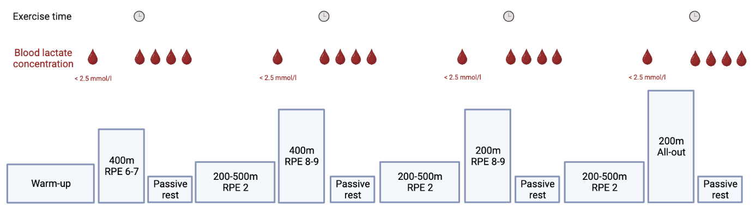
Figure 1. Test protocol swimming tests. Subjects performed 4 exercise bouts of 200-400m at RPE 6-10. BLC before and after each exercise bout and exercise time was measured.

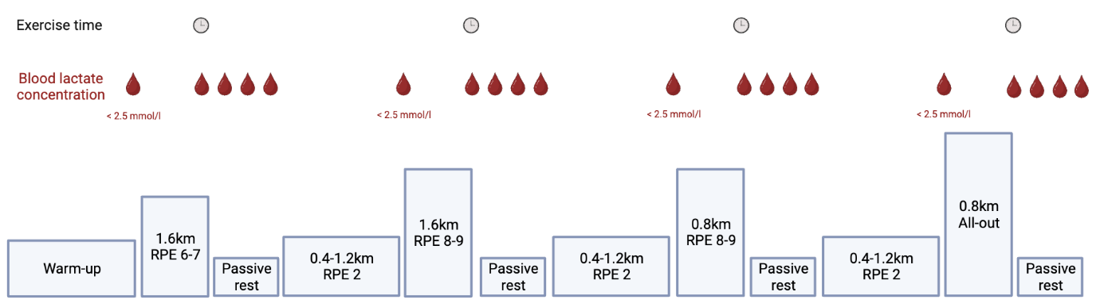
Figure 2. Test protocol running tests. Subjects performed 4 exercise bouts of 800-1600m at RPE 6-10. BLC before and after each exercise bout and exercise time was measured.

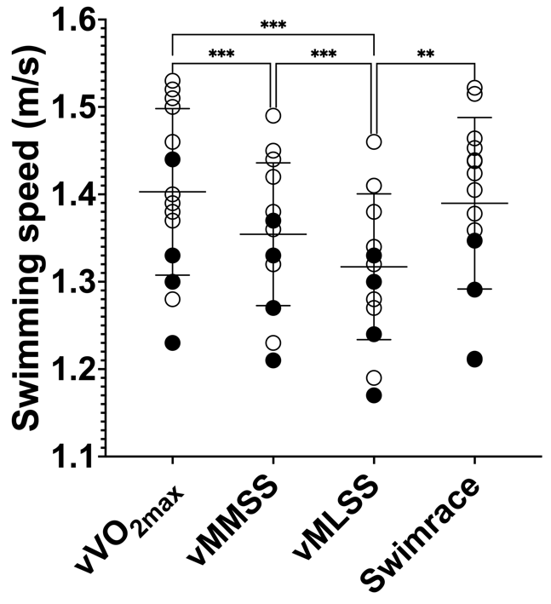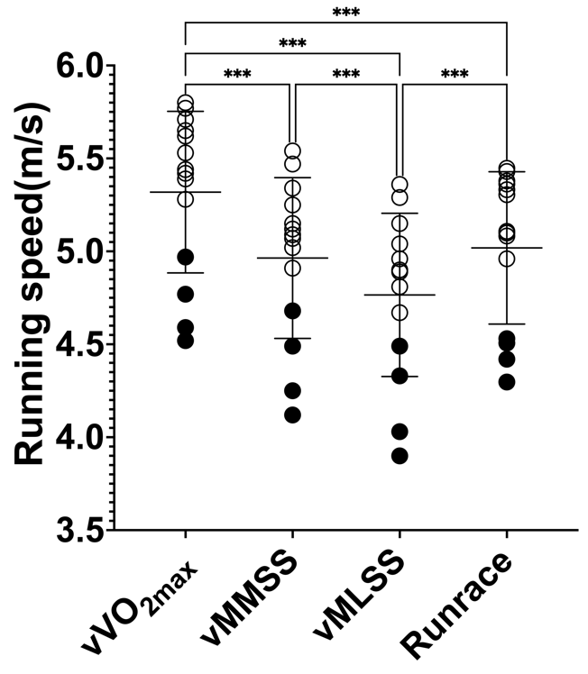
Figure 3. Swimming (Left panel) and running (Right panel) speed at $\dot{V}$O_{2max}, MLSS, MMSS and during the triathlonrace. Individual and mean±SD data. Open circles represent the data of the male subjects, closed circles represent the data of the female subjects. Anova. **** p<0.0001, *** p<0.001, ** p<0.01, * p<0.05, ns p>0.05

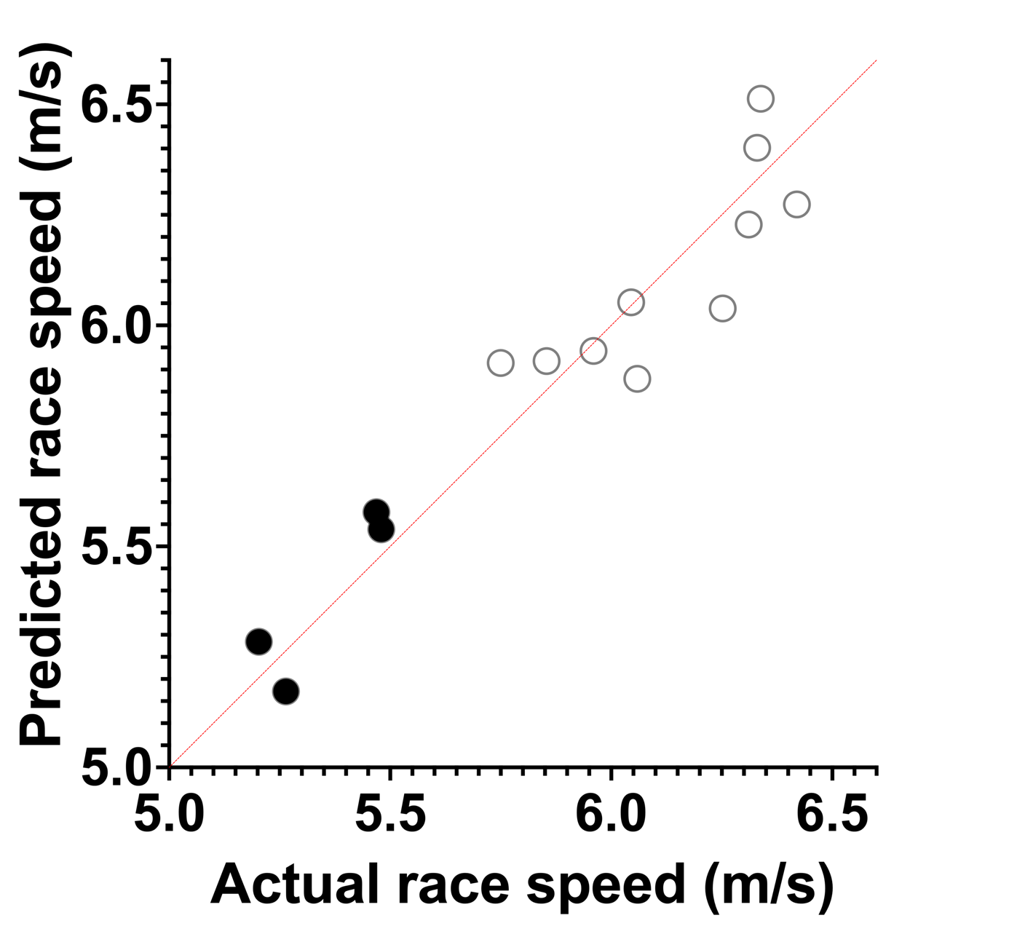
Figure 4. Actual triathlon racing speed (m·s⁻¹) versus predicted racing speed (m·s⁻¹). The red line indicates the line of identity. Open circles represent the data of the male subjects, closed circles represent the data of the female subjects.

